



|  |  |  |  |
| --- | --- | --- | --- |
| Member | Student # | Contribution | Signature |
| Benjamin Peh | 6098101 | Contributed | *Benjamin Peh* |
| Darren Lee | 6271698 | Contributed | *Darren Lee* |
| Yiu Cheung Tin | 5987593 | Contributed | *Yiu Cheung Tin* |
| Leonard Chan | 6270591 | Contributed | *Leonard Chan* |
| Mohamed Shafiq | 6098253 | Contributed | *Mohamed Shafiq* |
| Benny Peh | 6098125 | Contributed | *Benny Peh* |





Use Case Diagrams…………………………………………………………………………………………………..……….…………….3

Use Case Descriptions…………………………………………………………………………………………....…………………….6

Sequence Diagrams.……………………..……………………………………..………...………………..……….……………….20

Class Diagrams...………...…..…………………………………………..………...……..……………...………….……………….32

Boundary Control Entity Diagrams..………………………..………...……..…………....………….……………….39

Data Persistence Diagrams...………...…..……………………………………………….....………....……..………...43

Data Wireframe.………...…..………………………………………………………...………...……..…..……….………………….47

Sprint Progress.………...…..………………………………………………………...………...……..…..……….………………….53

Meeting Minutes…..………………………………………………………...………...……..…..……….…………………………….57

Test Cases.…..…………………………………………………...………...……..…..……….…………………………………………...65

Use Case Diagrams

Tour Guide Use Case

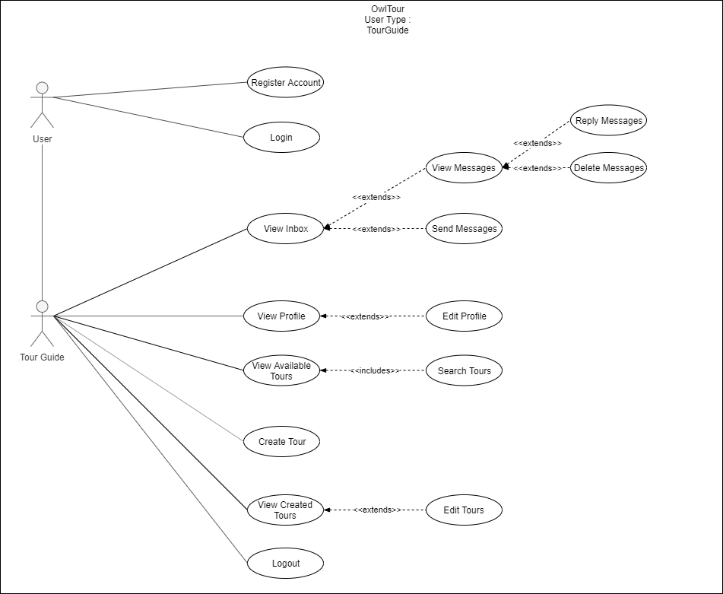

Tourist Use Case

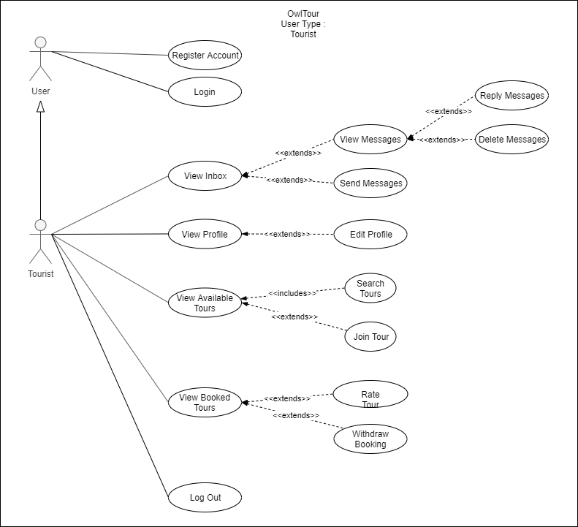

Tour Guide/Tourist/Admin Use Case

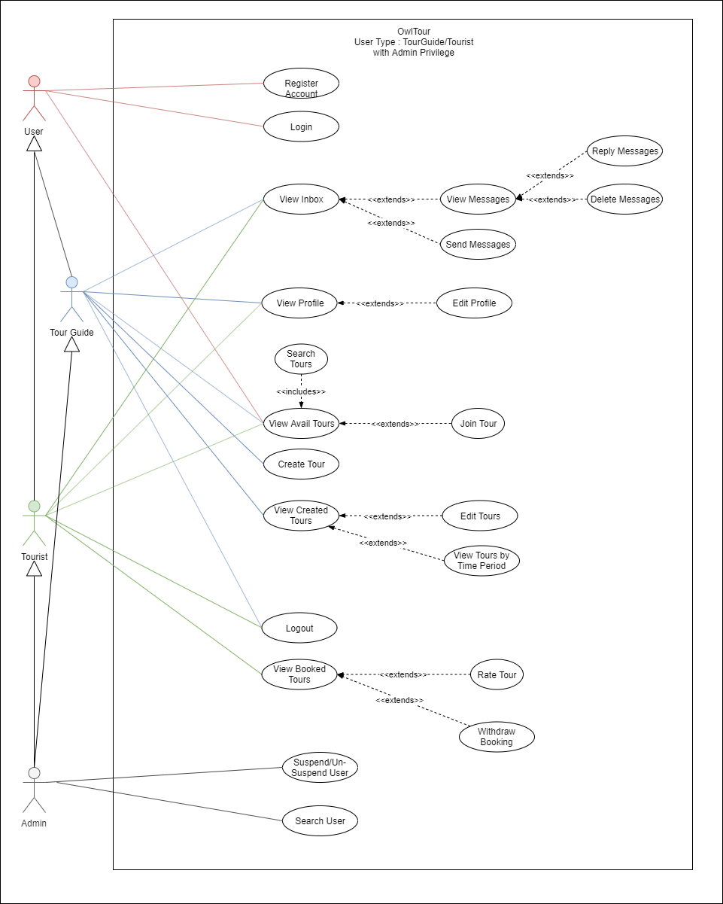

Use Case Description (Sprints 1 - 4)

|  |  |
| --- | --- |
| Use Case Name #1 and #11: As a Tourist/Tour Guide, I want to be able to create an account securely by entering my name, email address, a password and username, so that I can start using the application. | |
| Actors | Unregistered users |
| Description | Unregistered user enters the website to register for an account |
| Trigger | Actor clicks on the “Register for an Account” button |
| Precondition | Actor has not registered an account with the website |
| Post condition | Actor has successfully registered an account with the website |
| Normal Flow | Actor visits the website and clicks on “Register for an Account”.  Actor enters fills up registration form.  Once information has been keyed, click “Register” |
| Sub-Flow and Exceptions | > If a username or email entered is already saved in the database --  system will request user to enter a different username/email   address. > Clicking register when information is not filled up -- system will request  user to enter valid information  > Actors accidentally clicks “back” -- system asks if Actor wants to stop  registration process |

|  |  |
| --- | --- |
| Use Case Name #2 and #12: As a Tourist/Tour Guide, I want to be able to edit my user profile name, email address, password and username , so that I can update my particulars to the current status. | |
| Actors | Tourist/Tour Guides |
| Description | To update information for the Tourists/Tour Guides |
| Trigger | Tourist/Tour Guides clicks on “Edit Profile” |
| Pre-Conditions | Must have an account registered with the website |
| Post condition | Tourist/Tour Guide has successfully updated their account |
| Normal Flow: Description | Tourist/Tour Guide clicks on “Edit Profile”  Profile edited with all information filled up properly  Tourist/Tour Guide clicks “Update Profile” |
| Normal Flow: Post-Conditions | Profile information is saved and updated |
| Sub-Flow and Exceptions | > Information is not filled up properly -- system requests the information  to be filled up properly  > There are blanks in some of the requested information -- system  requests that the information to be filled up |



|  |  |
| --- | --- |
| Use Case Name #18: As a Tour Guide, I am able to choose an area/region that I am specialised in. | |
| Actors | Tour Guide/Tour Guide-to-be |
| Description | Tour Guides are to choose which area/region they are familiar with to give tours at. |
| Trigger | When registering/editing a profile of an account as a Tour Guide, there will be a prompt to ask for a specialised region. |
| Pre-Conditions | Must have a Tour Guide account or Actor is going to register for a Tour Guide account. |
| Post condition | Tour Guide account is updated with a specialised area. |
| Normal Flow: Description | Tour Guide clicks on “Edit Profile” Tour Guide enters area he is specialised in Tour Guide clicks “Update Profile”  Tour Guide-to-be clicks “Register for an Account”  Tour Guide-to-be enters area he is specialised in and all other information relevant to creating an account  Tour Guide-to-be clicks “Register” |
| Normal Flow: Post-Conditions | Tour Guide profile updated with specialised area Tour Guide-to-be creates an account with specialised area |

|  |  |
| --- | --- |
| Use Case Name #20: As an Admin, I want to be able to suspend/unsuspend Tour Guide accounts. | |
| Actors | Admin |
| Description | Admin can suspend or unsuspend a selected Tour Guide account |
| Trigger | Admin can press “Suspend” or “Un-suspend” button |
| Pre-Conditions | Must have an account with Admin privileges. |
| Post condition | Tour Guide account is suspended/unsuspended. |
| Normal Flow: Description | Admin clicks on desired tour guide Admin clicks on “Suspend Account” if account is not suspended OR  Admin clicks on “unsuspend account” if account is suspended |
| Normal Flow: Post-Conditions | Tour Guide account is suspended/unsuspended. |

|  |  |
| --- | --- |
| Use Case Name #40: As an Admin, I want to be able to suspend/unsuspend Tourist accounts. | |
| Actors | Admin |
| Description | Admin can suspend or unsuspend a Tourist account |
| Trigger | Admin can select a Tourist and suspend or un-suspend the account. |
| Pre-Conditions | Must have an account with Admin privileges. |
| Post condition | Tour Guide account is suspended/unsuspended. |
| Normal Flow: Description | Admin clicks on Tourist’s profile Admin clicks on “Suspend Account” if account is not suspended OR  Admin clicks on “unsuspend Account” if account is suspended |
| Normal Flow: Post-Conditions | Tourist account is suspended/unsuspended. |



|  |  |
| --- | --- |
| Use Case Name #75: As a User, I would like my program to prompt me for valid data when registering | |
| Actors | User |
| Description | Prompts for valid information when registering a new account. |
| Trigger | When registering an account with incomplete information. |
| Pre-Conditions | Is an unregistered User. |
| Post condition | Prompts for valid information. |
| Normal Flow: Description | User registers for an account User clicks “Register” without filling in correct information |
| Normal Flow: Post-Conditions | Program prompts for valid information. |

|  |  |
| --- | --- |
| Use Case Name #76: As a User, I would like my program to prompt me for invalid login when entering the wrong username/password combination | |
| Actors | User |
| Description | Prompts for valid information when logging in. |
| Trigger | When logging in an account with the wrong username/password combination. |
| Pre-Conditions | N/A |
| Post condition | Prompts for valid information. |
| Normal Flow: Description | User attempts to login User clicks “Login” without filling in with the correct information |
| Normal Flow: Post-Conditions | Program prompts for valid information. |

|  |  |
| --- | --- |
| Use Case Name #84: As a Tourist, i would like to be able to log out from my current session | |
| Actors | Tourist |
| Description | Tourist to press log out button |
| Trigger | Tourist clicks on the “Logout” button |
| Precondition | Tourist successfully logged into the account |
| Post condition | Tourist has successfully logged out from the website |
| Normal Flow | Tourist logs in through login page  Tourist presses logout button |

|  |  |
| --- | --- |
| Use Case Name #83: As a Tour Guide, i would like to be able to log out from my current session | |
| Actors | Tour Guide |
| Description | Tour Guideto press log out button |
| Trigger | Tour Guideclicks on the “Logout” button |
| Precondition | Tour Guidesuccessfully logged into the account |
| Post condition | Tour Guidehas successfully logged out from the website |
| Normal Flow | Tour Guide logs in through login page  Tour Guide presses logout button |

|  |  |
| --- | --- |
| Use Case Name #3: As a Tourist, I want to be able to choose between being a tourist and a tour guide, so that I’m able to use the account for work and leisure | |
| Actors | Tourist |
| Description | Tourist enter edit profile page to choose between tourist and tour guide |
| Trigger | Tourist click on edit profile button |
| Precondition | Must have an account that is tourist |
| Post condition | Tourist switch to the role they want |
| Normal Flow | Tourist enter profile page  Tourist click on edit profile  Tourists choose their desire role  Tourist click on update profile |
| Sub-Flow and Exceptions | > Clicking update profile when there is no role selected -- system will request to  select a role  > Tourist press cancel, returns back to original value |



|  |  |
| --- | --- |
| Use Case Name #4: As a Tourist, I want to be able to view a list of tours available, so that I can choose which tours are available. | |
| Actors | Tourist |
| Description | Tourist enter tour page to view list of tours available |
| Trigger | Tourist click on Tours button |
| Precondition | Must have a tourist role account registered |
| Post condition | Tourist entered tours page to view list of tours |
| Normal Flow | Tourist click on Tours button  Tourist entered Tours page which will show a list of Tours |

|  |  |
| --- | --- |
| Use Case Name #8 and #81: As a Tourist, I want to be able to book for different tours. | |
| Actors | Tourist |
| Description | Tourist enter tour page to view list of tours and book tours that does not clash in timing |
| Trigger | Tourists choose desired tour and click the join button |
| Precondition | Must have a tourist role account registered |
| Post condition | Tourist booked desired tours |
| Normal Flow | Tourist click on Tours button  Tourist entered Tours page which will show a list of Tours  Tourists choose desired tour  Tourist click the join button to join the chosen tour |
| Sub-Flow and Exceptions | > If Tourist click the join button on a tour that had been joined, system will tell  tourists that he had joined the tour  > Tour guide will not be able to see their own tours in this page also if by any chance  it appears, they also can’t join their own tour |

|  |  |
| --- | --- |
| Use Case Name #38: As a Tourist, I want to be able to withdraw from a booking | |
| Actors | Tourist |
| Description | Tourist cancel booked tour from booked tours page |
| Trigger | Tourist choose booked tour and click cancel tour button |
| Precondition | Must have a tourist role account registered |
| Post condition | Tourist withdraw from booked tour |
| Normal Flow | Tourist click on Booked Tours button  Tourist entered Booked Tours page which will show a list of booked tours  Tourists choose their desired booked tour  Tourist click cancel tour button to withdraw from booked tour |



|  |  |
| --- | --- |
| Use Case Name #13 and #16: As a Tour Guide, I want to be to create tours for tourists.  As a Tour Guide, I want to be able to host a couple of different tours . | |
| Actors | Tour Guide |
| Description | Tour Guide create tours for tourists from Create a Tour page |
| Trigger | After filling the necessary information at Create a Tour page, Tour Guide click the submit button |
| Precondition | Must have a Tour Guide role account registered |
| Post condition | Tour Guide created a Tour |
| Normal Flow | Tour Guide click on Create a Tour button  Tour Guide entered Create a Tour page  Tour Guide fill in the necessary information for the tour  Tourist click submit button to create tour |
| Sub-Flow and Exceptions | > Clicking the submit button without filling all the information, the system will tell  tour guide please fill in all the information  > Choosing a date that is before or equal to the current date, the system will tell tour  guide please only choose valid date |

|  |  |
| --- | --- |
| Use Case Name #39: As a Tour Guide, I want to able to postpone and edit tours | |
| Actors | Tour Guide |
| Description | Tour Guide edit/postpone tour at View Created Tour page |
| Trigger | Click edit on the desire tour from View Created Tour page |
| Precondition | Must have a Tour Guide role account registered |
| Post condition | Tour edited/postponed |
| Normal Flow | Tour Guide click on Viewed Created Tour button  Tour Guide entered Viewed Create Tour page  Tour Guide click edit on chosen tour  Tour Guide fill in the changes for the tour  Tourist click confirm edit button |
| Sub-Flow and Exceptions | > Clicking the confirm edit button without filling all the information, the system will  tell tour guide please fill in all the information  > Choosing a date that is before or equal to the current date, the system will tell tour  guide please only choose valid date  > If Tour guide click the edit button and there is a clash in timing with another  created tour, system will tell tour guide that he had created a tour for that timing |



|  |  |
| --- | --- |
| Use Case Name #79: As a Tourist, I would like to be able to view my profile | |
| Actors | Tourist |
| Description | Tourist view their own profile. |
| Trigger | Click Profile in the main menu. |
| Precondition | Must have a Tourist role account registered. |
| Post condition | Views profile. |
| Normal Flow | Tourist clicks on “Profile” in main menu  Tourist able to see their profile |

|  |  |
| --- | --- |
| Use Case Name #80: As a Tour Guide, I would like to be able to view my profile | |
| Actors | Tour Guide |
| Description | Tour Guide view their own profile. |
| Trigger | Click Profile in the main menu. |
| Precondition | Must have a Tour Guide role account registered. |
| Post condition | Views profile. |
| Normal Flow | Tour Guide clicks on “Profile” in main menu  Tour Guide able to see their profile |

|  |  |
| --- | --- |
| Use Case Name #6 and #82: As a Tourist, I want to be able to rate my tour guide, so that my tour guide is informed of my satisfaction level. | |
| Actors | Tourist |
| Description | After tour is completed/date is reached. Tourists will be able to rate the tour guide. |
| Trigger | Rate button is pressed on selected ended tour |
| Precondition | Must have a tourist role account registered  Tour date is over the current date aka ended |
| Post condition | Tour’s date is passed, rating is given to tour guide. |
| Normal Flow | Tourist clicks on Booked Tours.  Tourist select an ended tour  Tourists enters rating (Between 1 - 5)  Tourist click the submit button to pass rating. |
| Sub-Flow and Exceptions | If tourist does not choose a rating, the system will prompt the user to select a rating. |

|  |  |
| --- | --- |
| Use Case Name #9 and #85: As a Tourist, I want to be able to search for a list of tours by their name, area or tour name and to be able to make a more informed decision. | |
| Actors | Tourist |
| Description | Tourist go to Tour page and search for his desire tour through the search bar |
| Trigger | Click search button after entering description in search bar with criteria selected |
| Precondition | Must have a tourist role account registered |
| Post condition | Tour page will filter and show based on text inputted and criteria |
| Normal Flow | Tourist clicks on Tours.  Tourist key in search description in search bar with his desire search criteria.  Tourist click search button |
| Sub-Flow and Exceptions | If the search criteria not selected, the system will tell Tourist to select a search criterion |



|  |  |
| --- | --- |
| Use Case Name #22: As a Tourist, I want to be able to send a message to the Tourist/tour guides, to be able to communicate with each other | |
| Actors | Tourist |
| Description | Tourist go to Inbox page, press new then select tour guide/tourist and input message |
| Trigger | Click the send button after inputting message |
| Precondition | Must have a tourist role account registered |
| Post condition | Message will be sent to designated Tourist/Tour Guide |
| Normal Flow | Tourist clicks on inbox page.  Tourist click new button  Tourist select a user from the list  Tourist type in message in message box  Tourist click send button |
| Sub-Flow and Exceptions | If the message box is empty, the system will prompt error – Please don’t send an empty message |

|  |  |
| --- | --- |
| Use Case Name #71: As a Tourist, I would like to able to reply my received message inbox. | |
| Actors | Tourist |
| Description | Tourist go to Inbox page, select message and press reply |
| Trigger | Click reply button after inputting message |
| Precondition | Must have a Tourist role account registered |
| Post condition | Message will be sent to designated user |
| Normal Flow | Tourist clicks on inbox page.  Tourist click on desired message to reply  Tourist type in message in message box  Tourist click reply button |
| Sub-Flow and Exceptions | If the message box is empty, the system will tell Tourist error – Please don’t send an empty message |



|  |  |
| --- | --- |
| Use Case Name #37: As a Tour Guide, I want to be able to send a message to the tourists/tour guide to be able to communicate with each other. | |
| Actors | Tour Guide |
| Description | Tour Guide go to Inbox page press new then select tour guide/tourist and input message |
| Trigger | Click the send button after inputting message |
| Precondition | Must have a Tour Guide role account registered |
| Post condition | Message will be sent to designated user |
| Normal Flow | Tour Guide clicks on inbox page.  Tour Guide click new button  Tour Guide select a user from the list  Tour Guide type in message in message box  Tour Guide click send button |
| Sub-Flow and Exceptions | If the message box is empty, the system will tell Tour Guide error – Please don’t send an empty message |

|  |  |
| --- | --- |
| Use Case Name #72: As a Tour Guide, I would like to able to reply my received message inbox. | |
| Actors | Tour Guide |
| Description | Tour Guide go to Inbox page, select message and press reply |
| Trigger | Click reply button after inputting message |
| Precondition | Must have a Tour Guide role account registered |
| Post condition | Message will be sent to designated user |
| Normal Flow | Tour Guide clicks on inbox page.  Tour Guide click on desired message to reply  Tour Guide type in message in message box  Tour Guide click reply button |
| Sub-Flow and Exceptions | If the message box is empty, the system will tell Tour Guide error – Please don’t send an empty message |

|  |  |
| --- | --- |
| Use Case Name #73: As a Tourist, I would like to able to delete message in my inbox. | |
| Actors | Tourist |
| Description | Tourist go to Inbox page, select message and press delete |
| Trigger | Press delete after selecting chosen message |
| Precondition | Must have a Tourist role account registered |
| Post condition | Message will be deleted from the user inbox |
| Normal Flow | Tourist clicks on inbox page.  Tourist click on desired message to reply  Tourist click delete button |

|  |  |
| --- | --- |
| Use Case Name #74: As a Tour Guide , I would like to able to delete message in my inbox. | |
| Actors | Tour Guide |
| Description | Tour Guide go to Inbox page, select message and press delete |
| Trigger | Press delete after selecting chosen message |
| Precondition | Must have a Tour Guide role account registered |
| Post condition | Tour Guide will be deleted from the user inbox |
| Normal Flow | Tour Guide clicks on inbox page.  Tour Guide click on desired message to reply  Tour Guide click delete button |

|  |  |
| --- | --- |
| Use Case Name #77: As a Tourist, I would like to be able to view the messages I have received | |
| Actors | Tourist |
| Description | Tourist go to Inbox page, check for received messages. |
| Trigger | Clicks “Inbox” from main menu or “Inbox” from sub-menu in the Inbox Page. |
| Precondition | Must have a Tourist role account registered. |
| Post condition | Able to view all the messages received. |
| Normal Flow | > Tourist clicks on “Inbox” in main menu  > Messages that are received are shown in the Inbox Page |

|  |  |
| --- | --- |
| Use Case Name #78: As a Tour Guide, I would like to be able to view the messages I have received | |
| Actors | Tour Guide |
| Description | Tour Guide go to Inbox page, check for received messages. |
| Trigger | Clicks “Inbox” from main menu or “Inbox” from sub-menu in the Inbox Page. |
| Precondition | Must have a Tour Guide role account registered. |
| Post condition | Able to view all the messages received. |
| Normal Flow | Tour Guide clicks on “Inbox” in main menu  Messages that are received are shown in the Inbox Page |

Sequence Diagram (Sprints 1 - 4)

Login Sequence Diagram

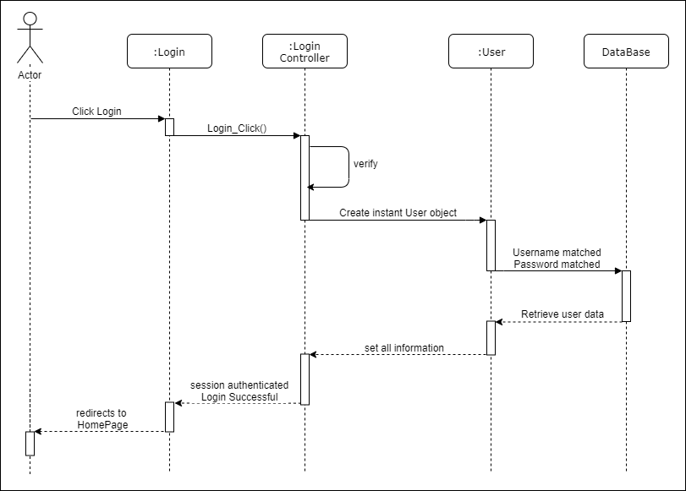



Register Sequence Diagram

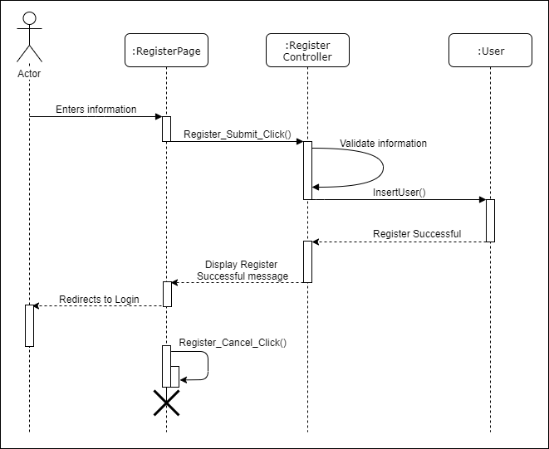

Edit Profile Sequence Diagram

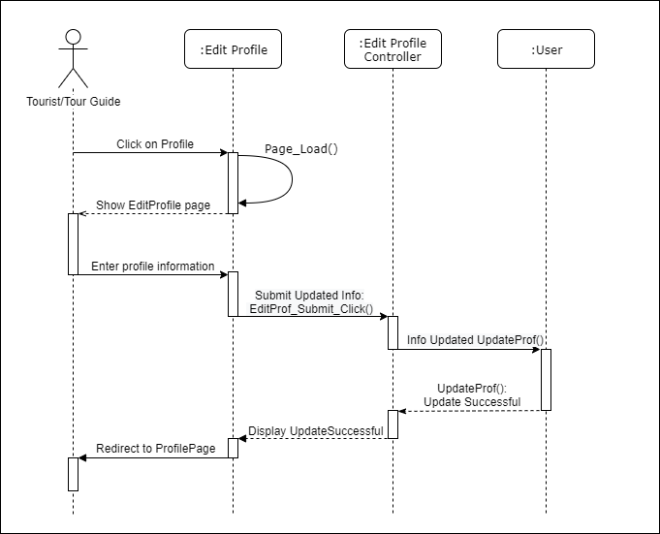

View Created Tours Sequence Diagram

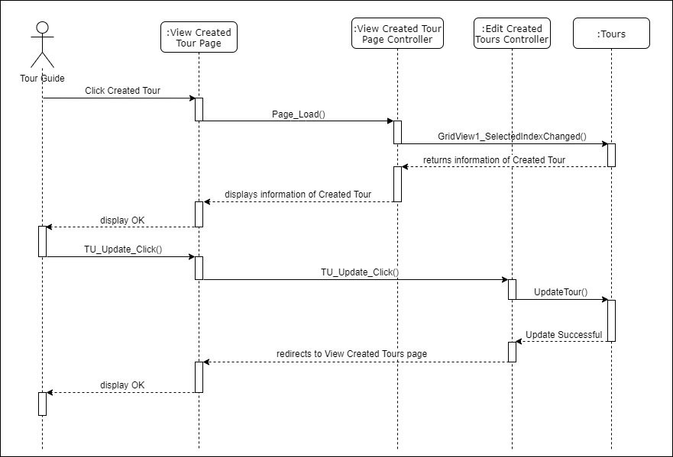

View Booked Tours Sequence Diagram

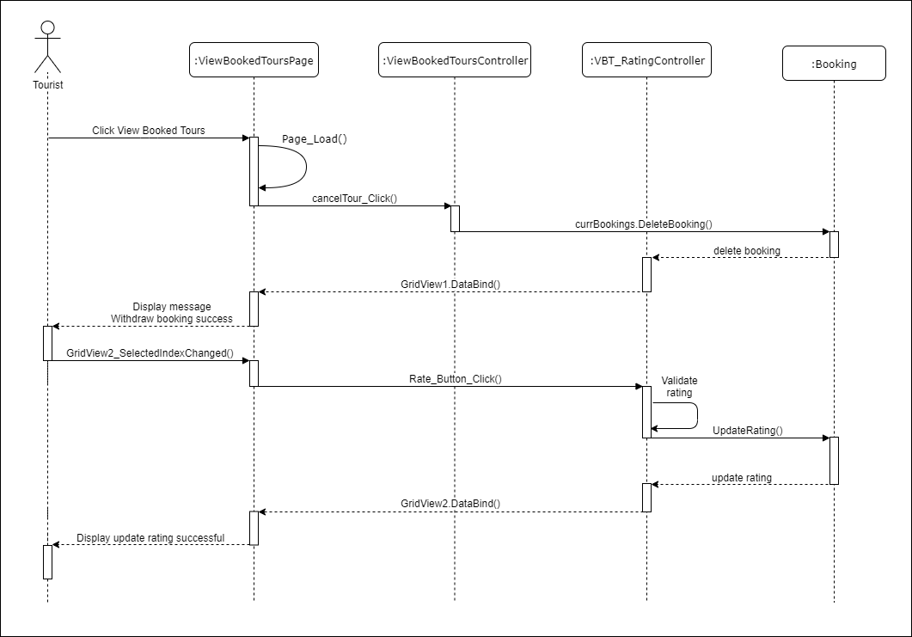

Create Tour Sequence Diagram

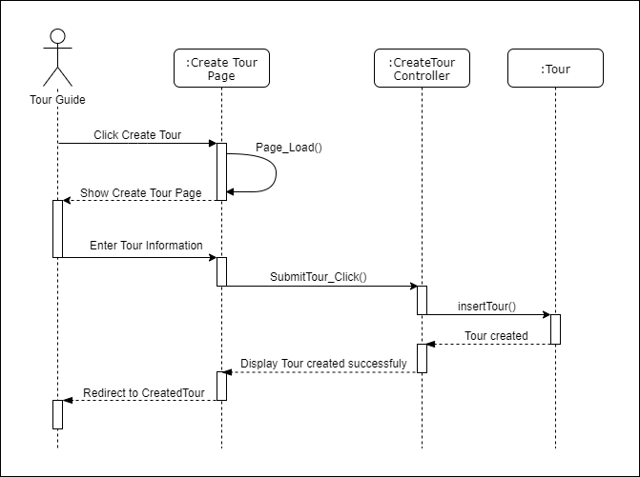

Booking Sequence Diagram

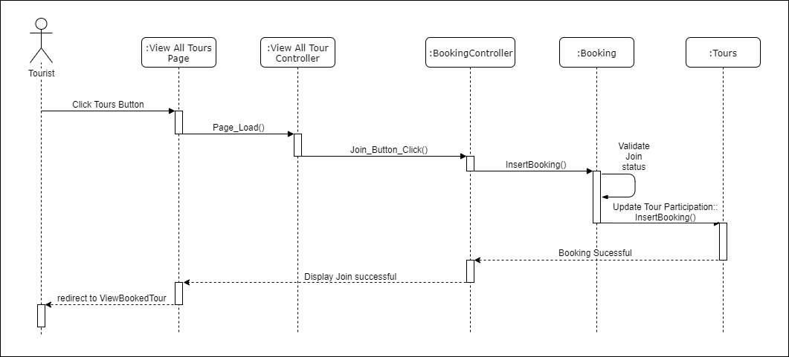

Reply Received Messages Sequence Diagram

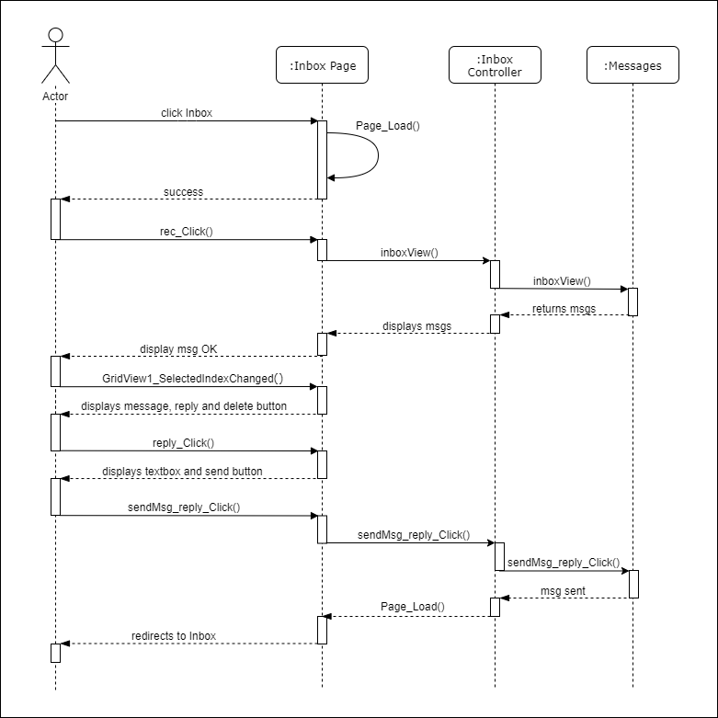

Send New Message Sequence Diagram

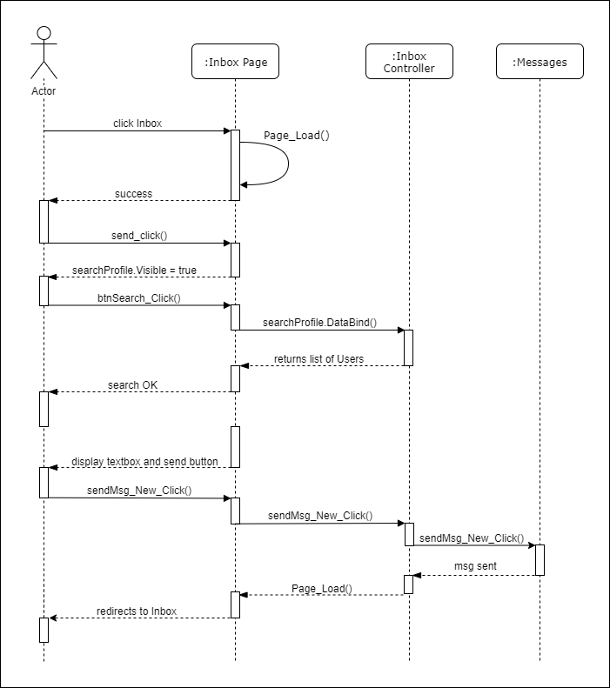

Delete Received Messages Sequence Diagram

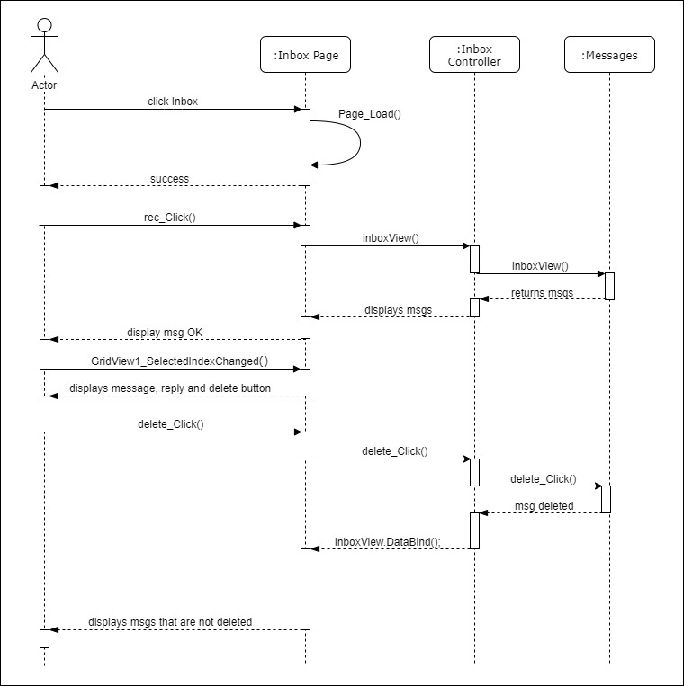

Search Users Sequence Diagram (Admin Suspend)

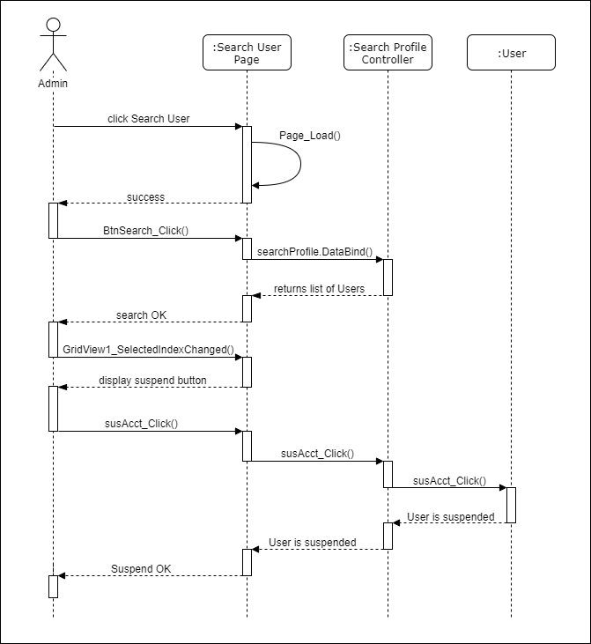

Search User Sequence Diagram (Admin Un-suspend)

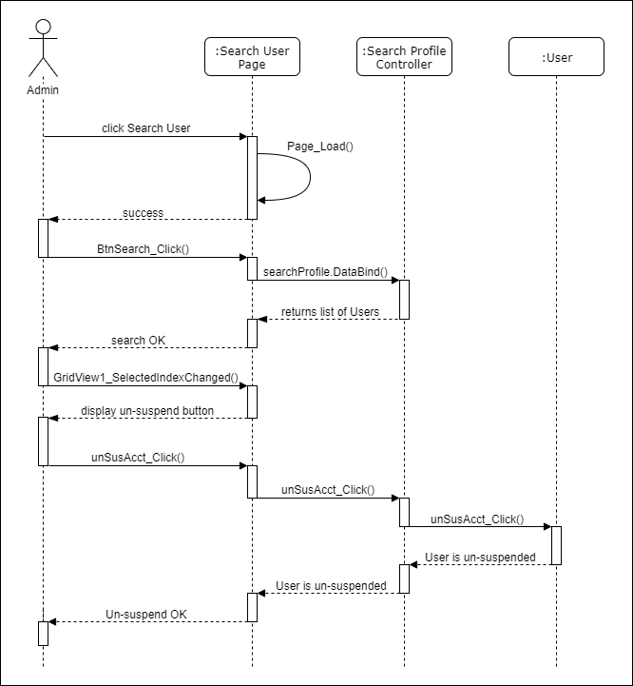

Class Diagrams

User Class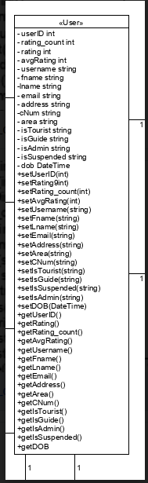

Tours Class

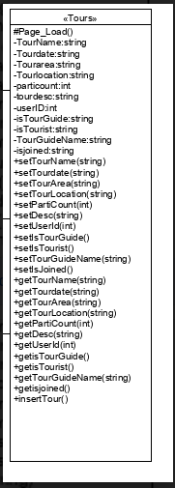

Bookings Class

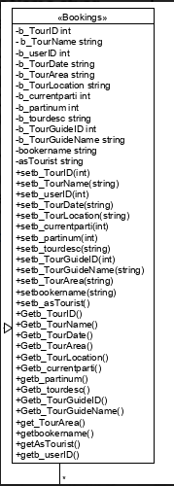

Class Diagrams (Accumulated over Sprints)

Owl Tours Class Diagram Part 1

Featuring relationships between USER Class & other partial classes.

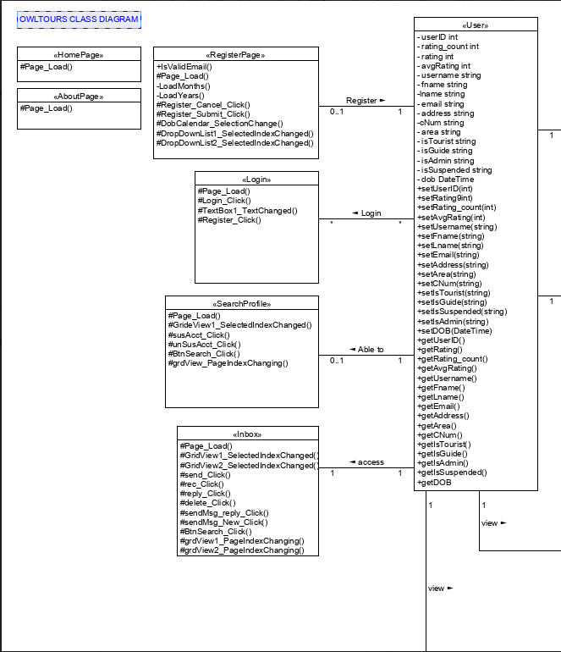

Owl Tours Class Diagram Part 2

Featuring relationships between Tours Class & other partial classes.

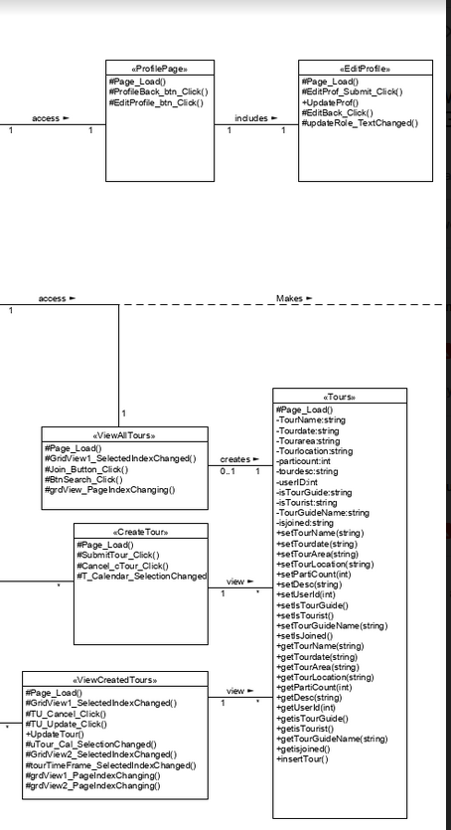

Owl Tours Class Diagram Part 3

Featuring relationships between Bookings Class & other partial classes.

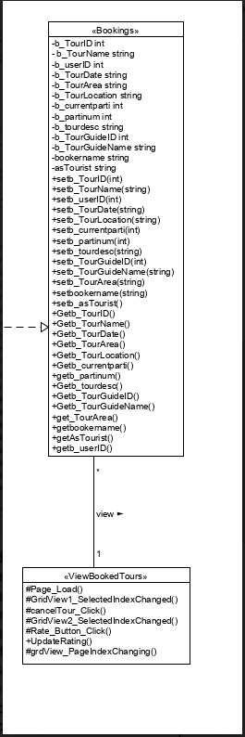

Owl Tours Class Diagram Overall

Featuring relationships between ALL Classes & other partial classes.

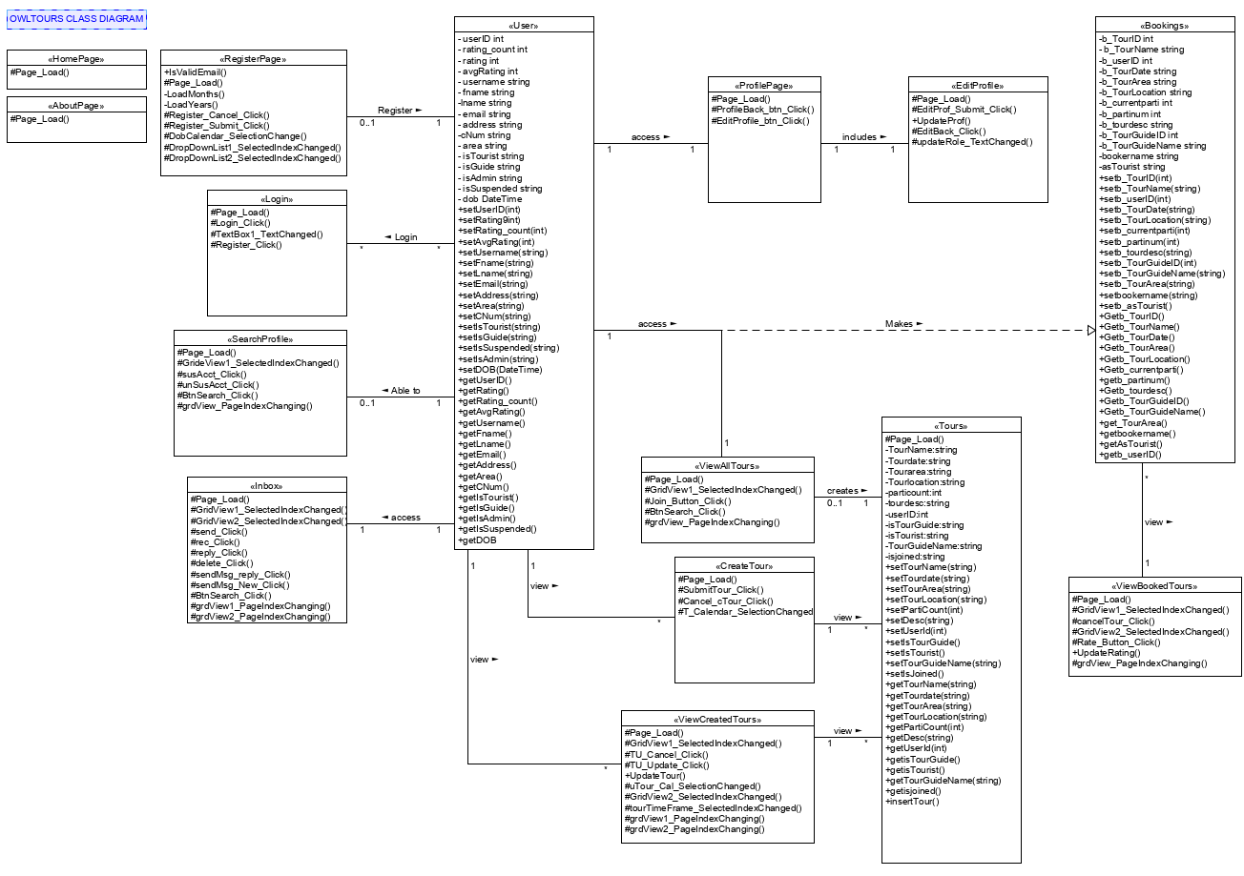

Boundary Control Entity Diagrams

BCE on USER entity to its partial classes.

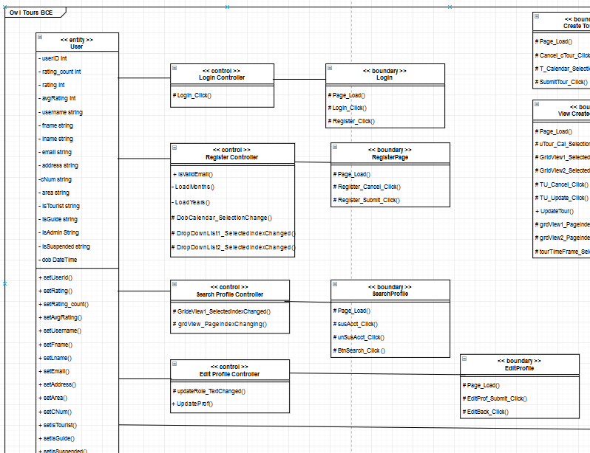

Tours Entity to View/Edit/Create Tours Controllers to Create/View Boundary

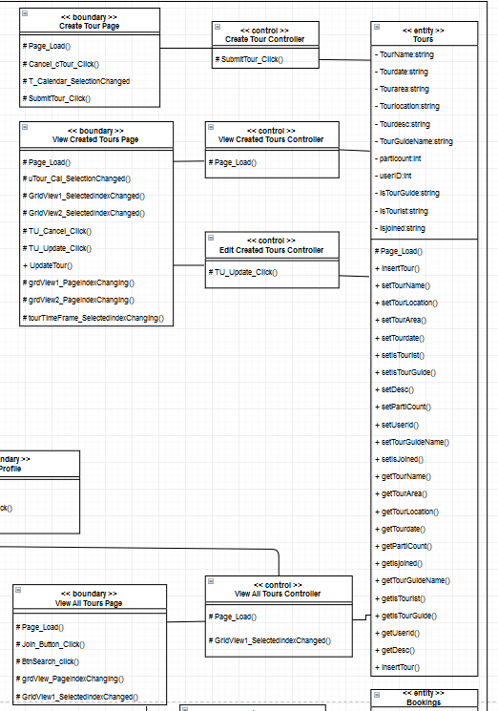

Bookings BCE

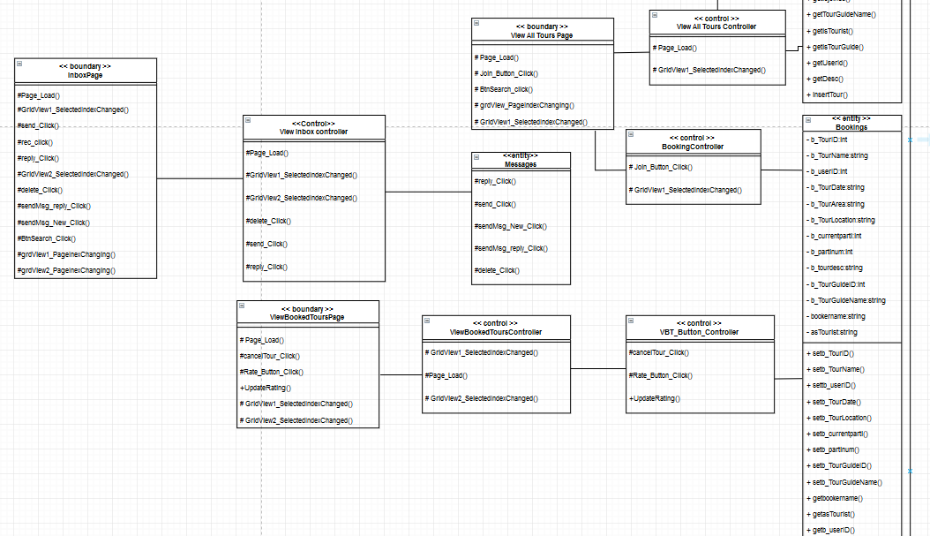

Overall BCE Image 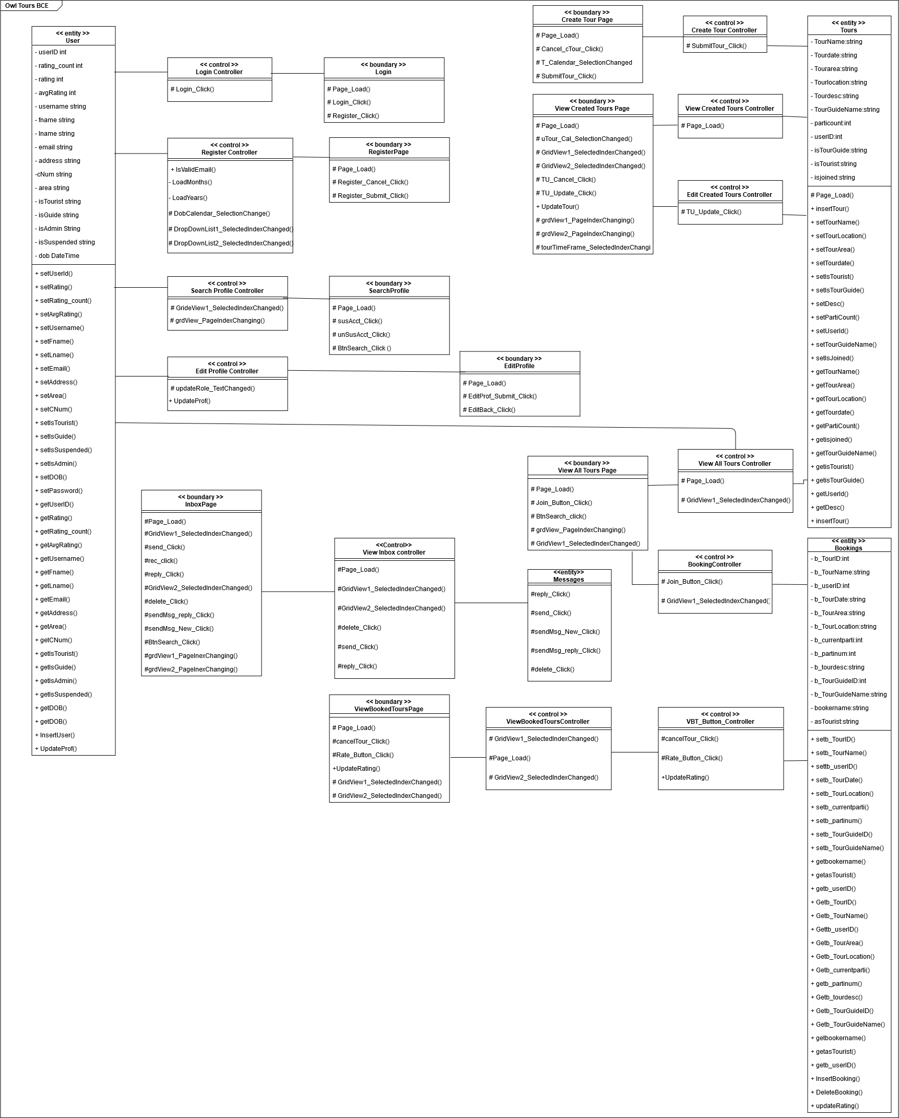

Data Persistence Diagrams

Relational Database 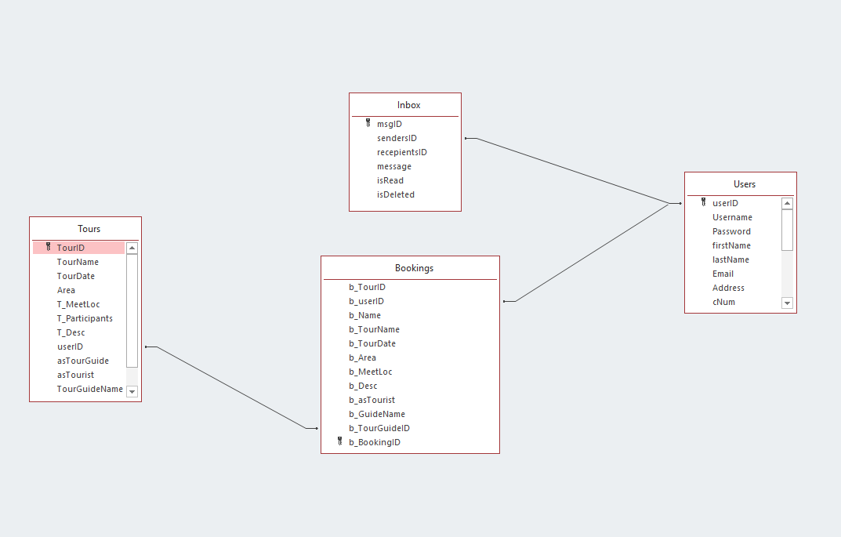

Sample Data from Microsoft Access DB

Inbox

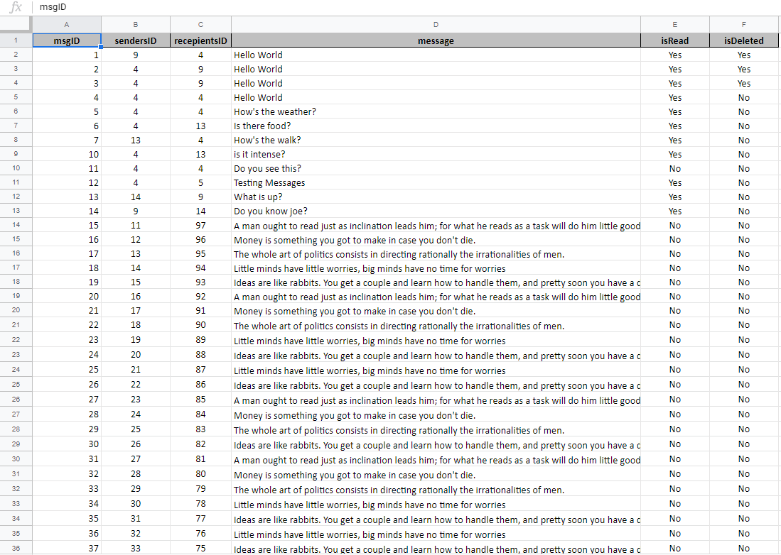

Sample Data from Microsoft Access DB

Users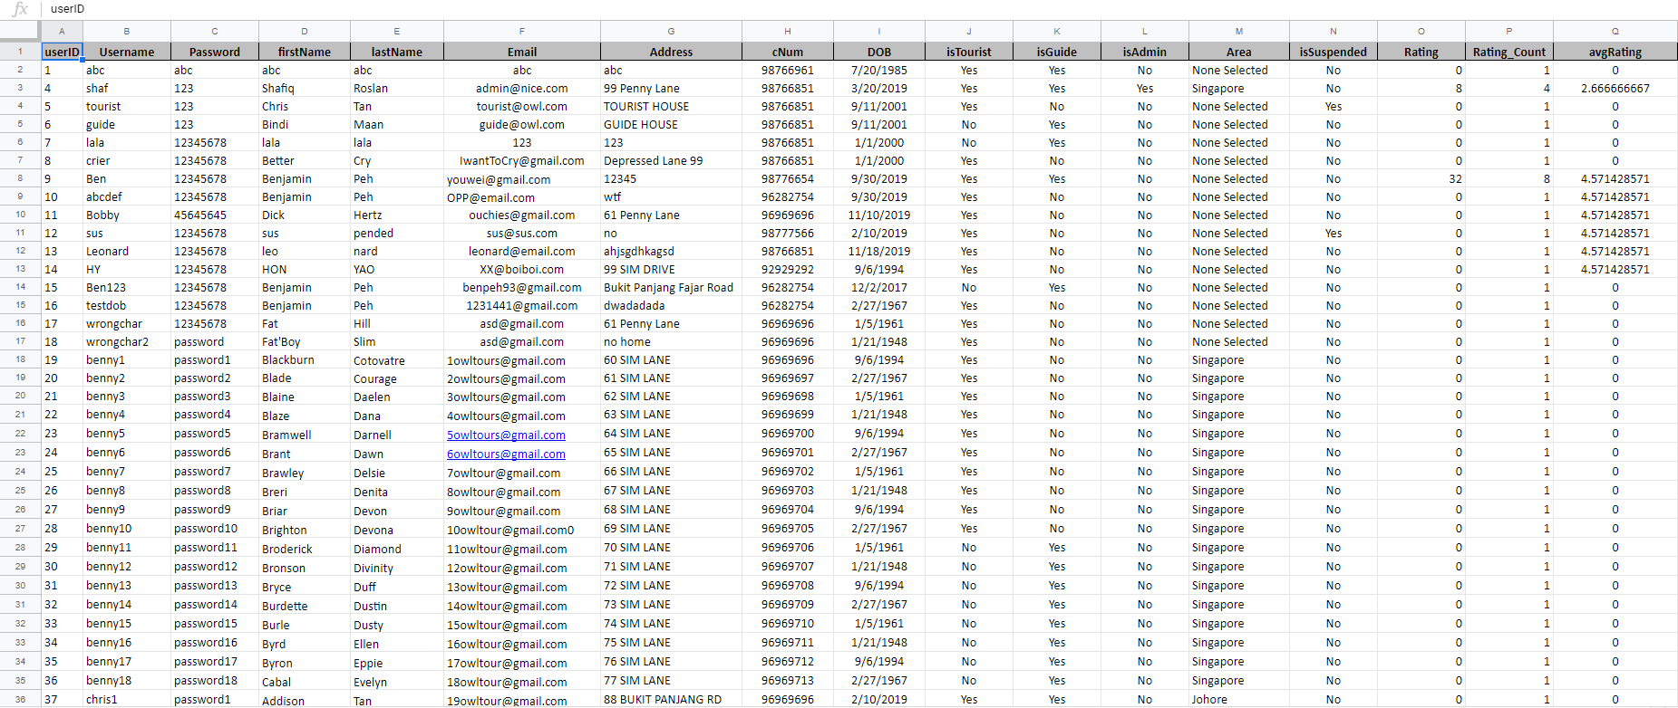

Sample Data from Microsoft Access DB

Tours

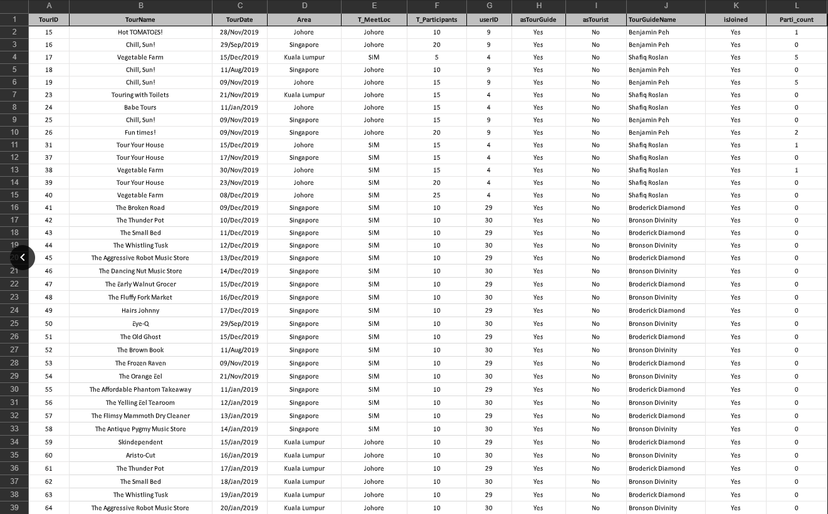

Data WireFrame

Home Page

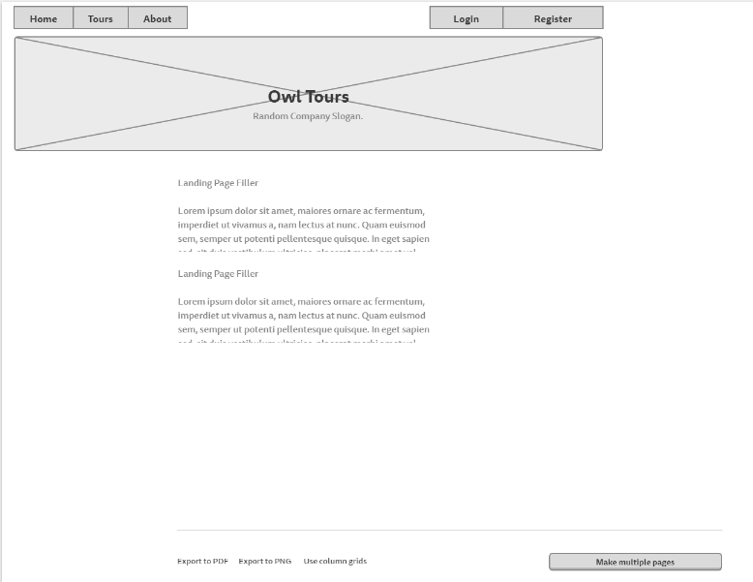

Login Page

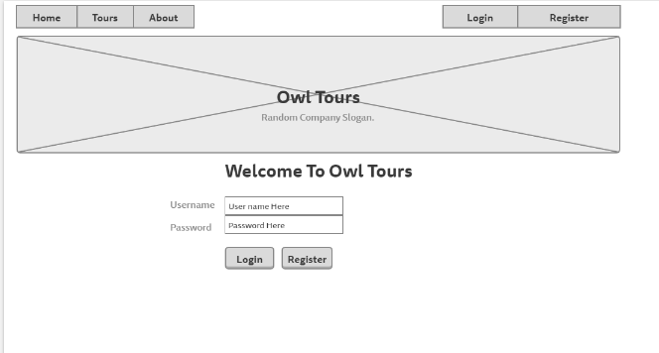

View All Tours Page

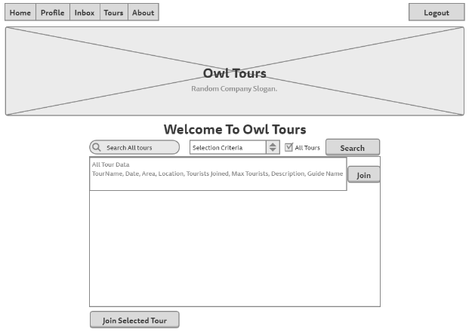

View Booked Tours Page

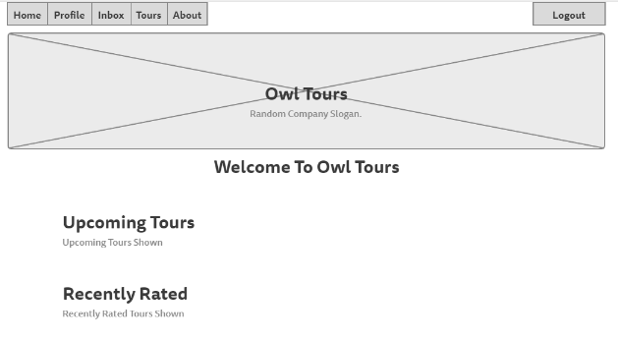

Inbox Page

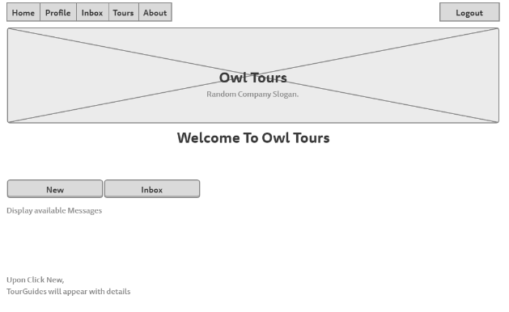

Profile Page

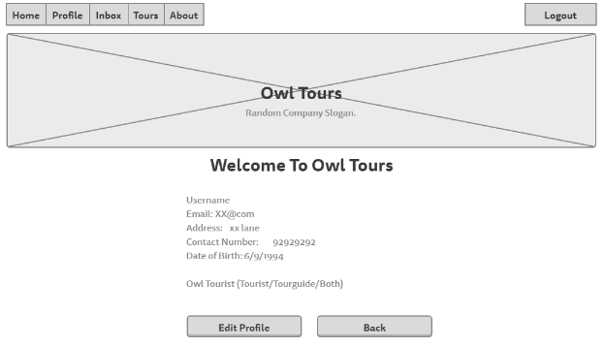

Edit Profile Page

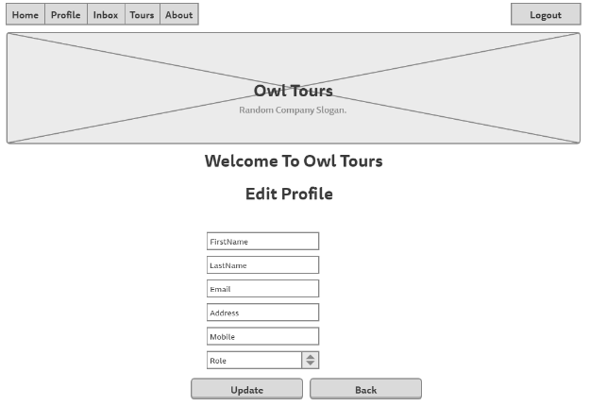

Create Tour Page

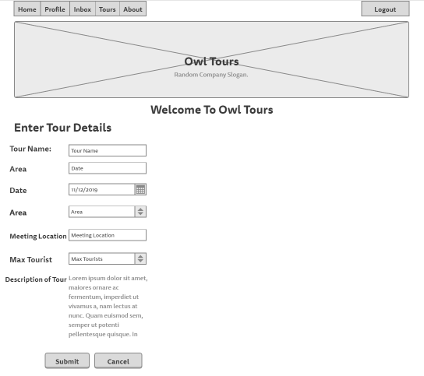

View Created Tours Page

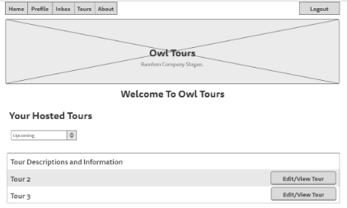

About Page

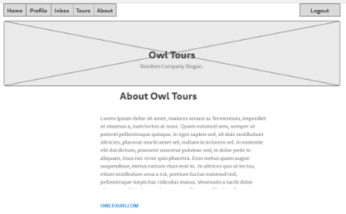

Register Page

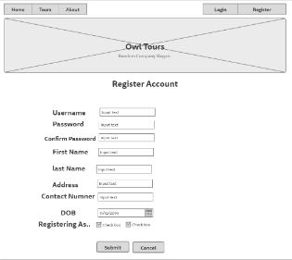

Search User Page

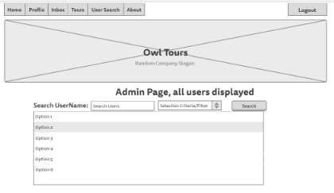

Sprint Progress

1st Sprint

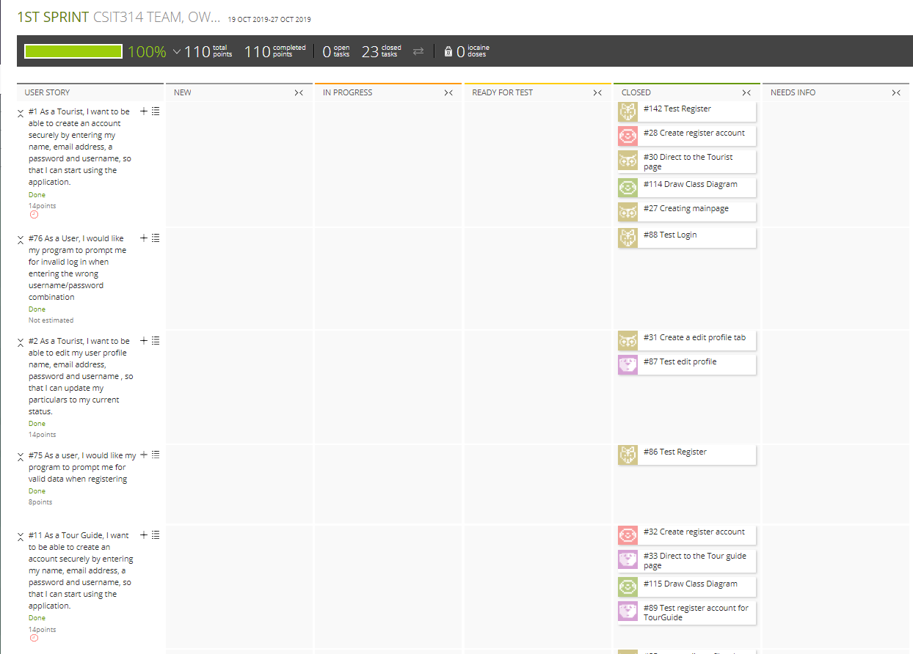

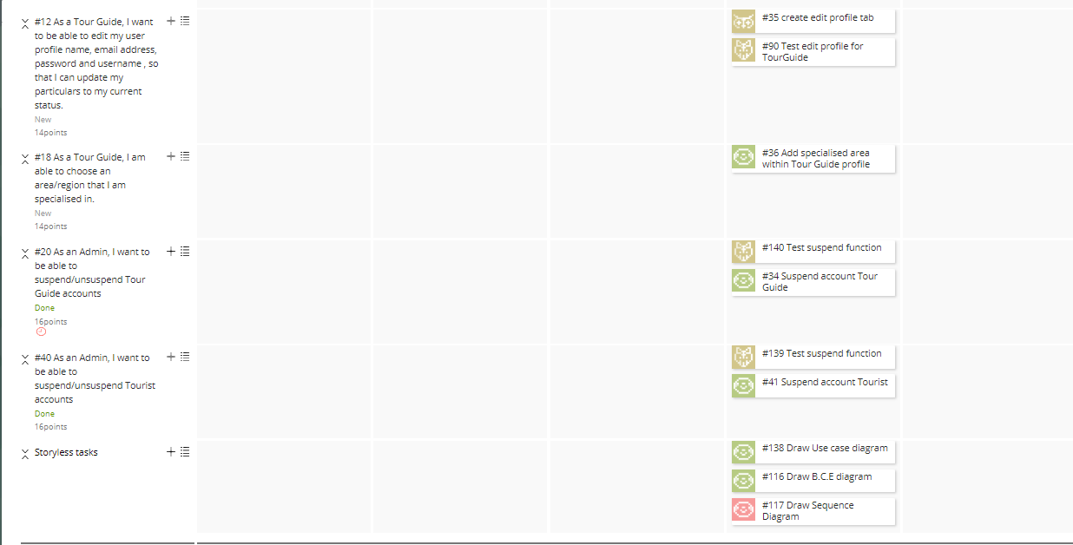

2nd Sprint

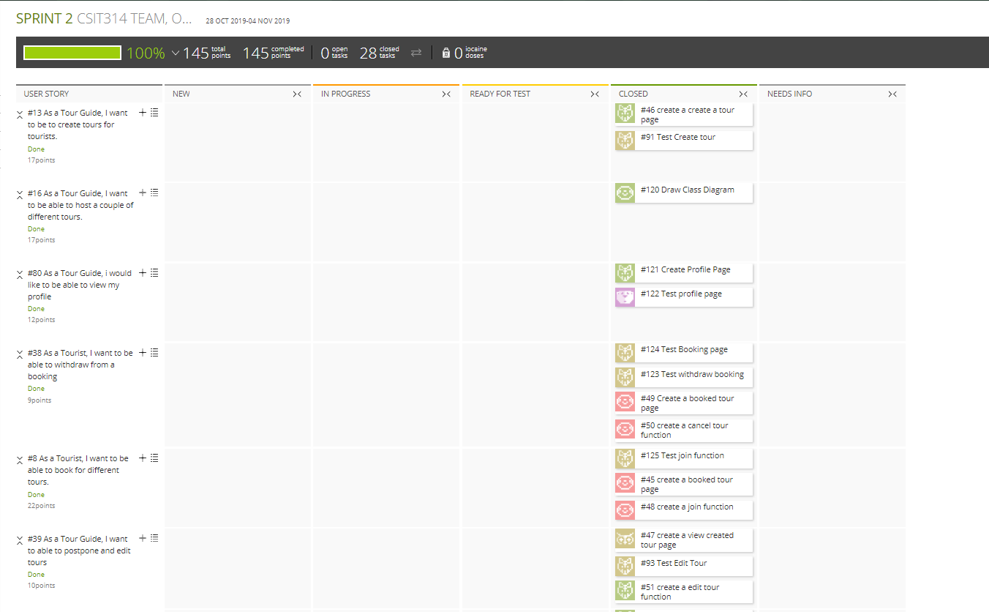

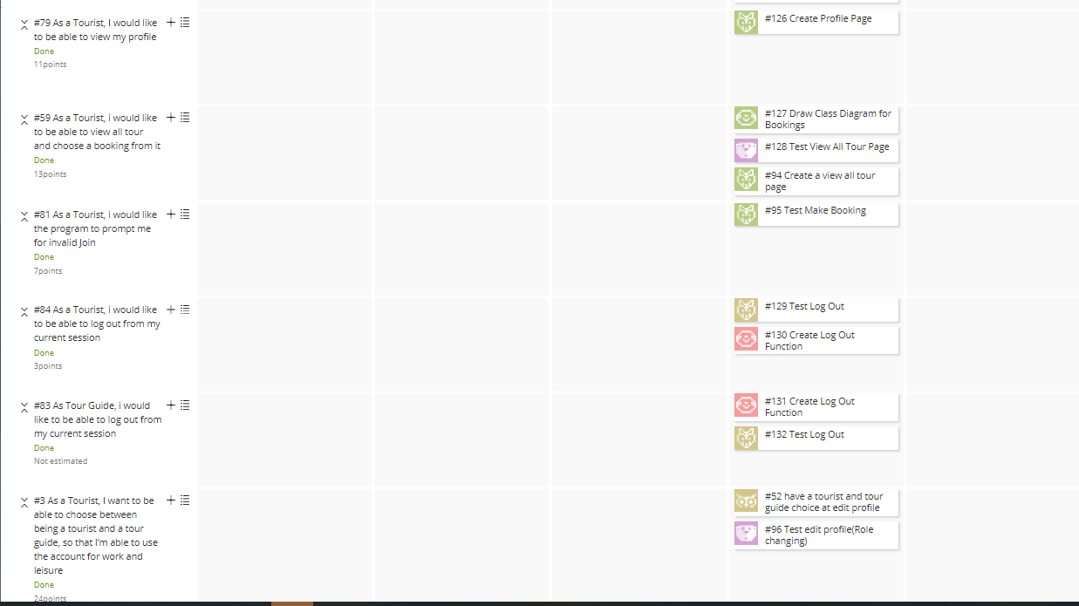

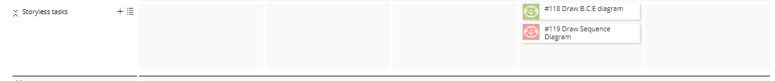

3rd Sprint

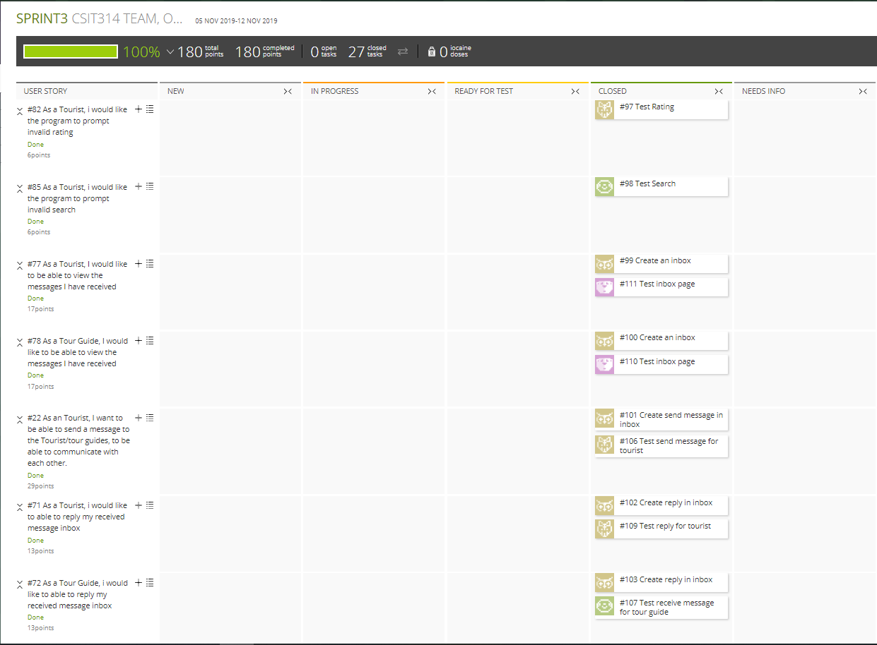

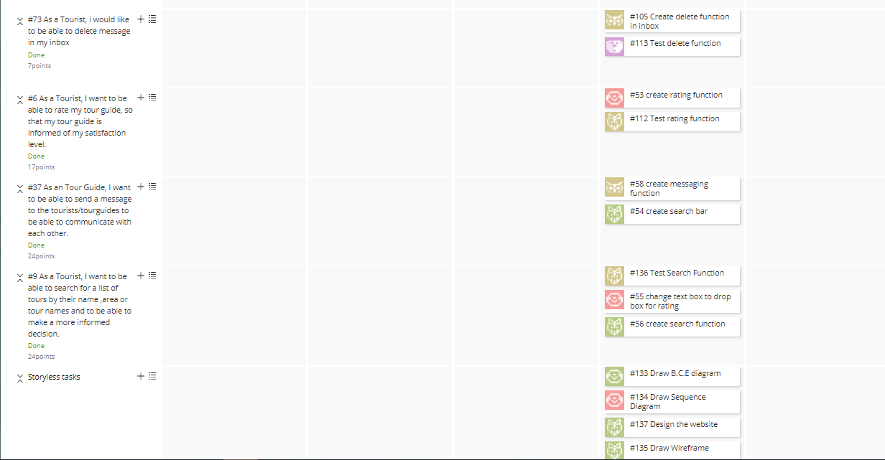

4th Sprint

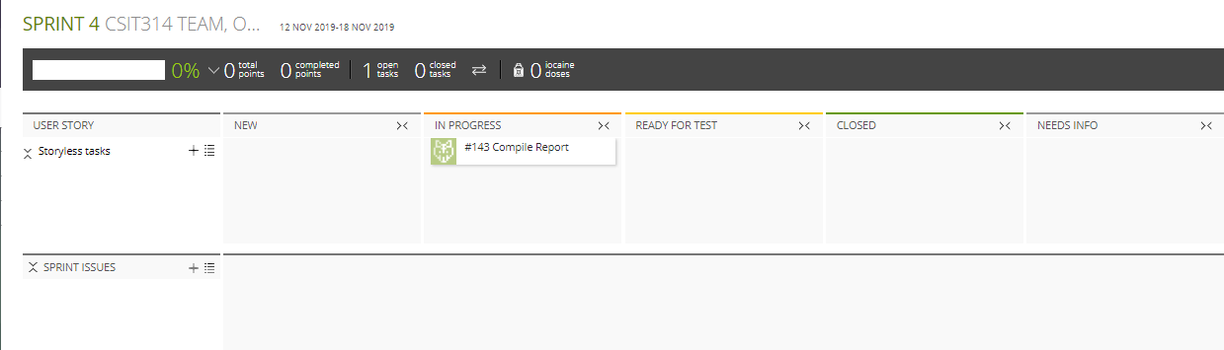

Meeting Minutes

21 October 2019

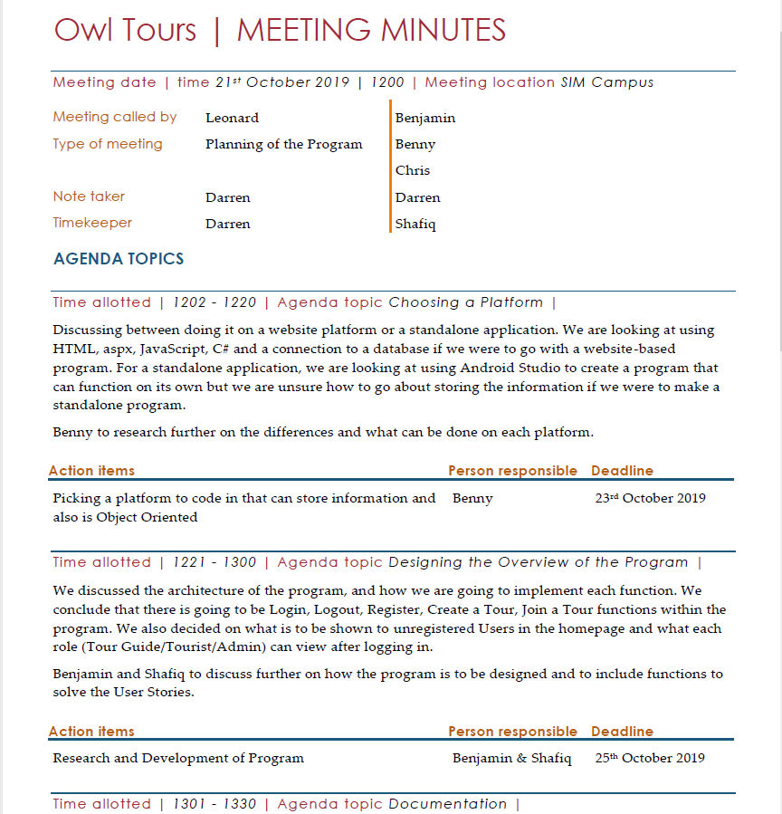

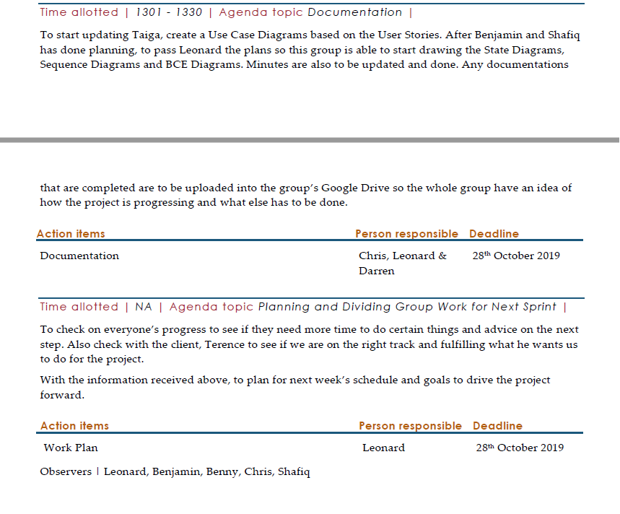

28 October 2019

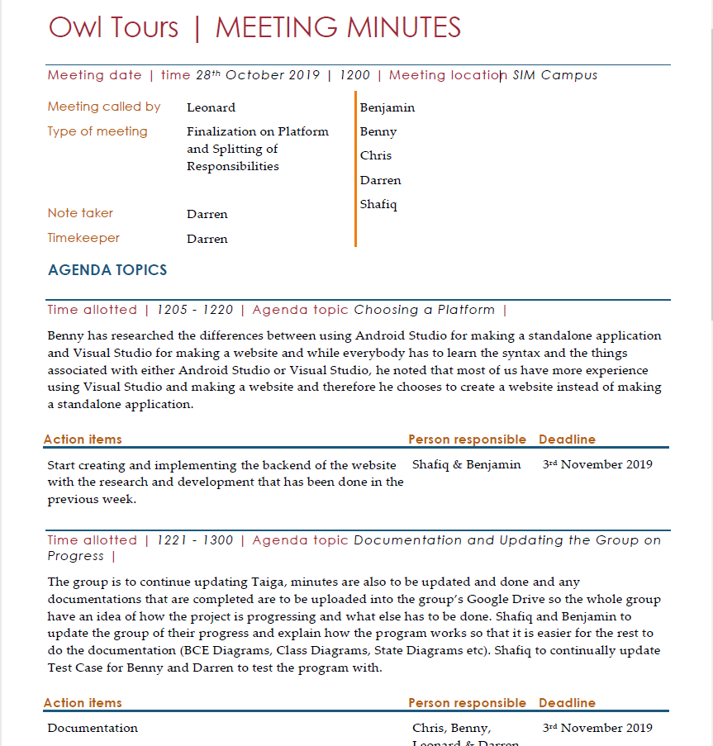

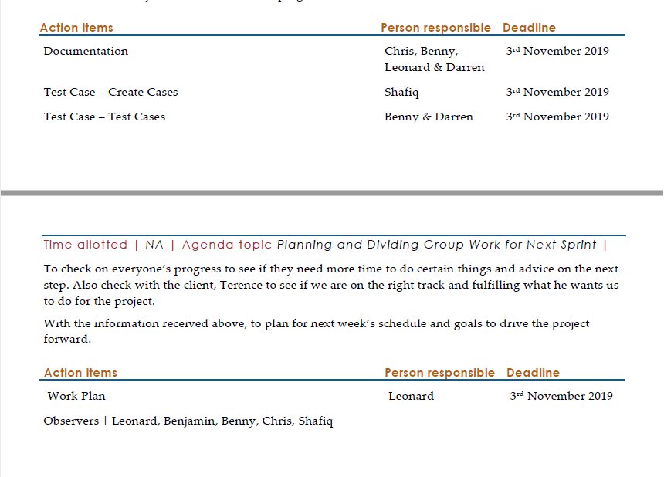

4 November 2019

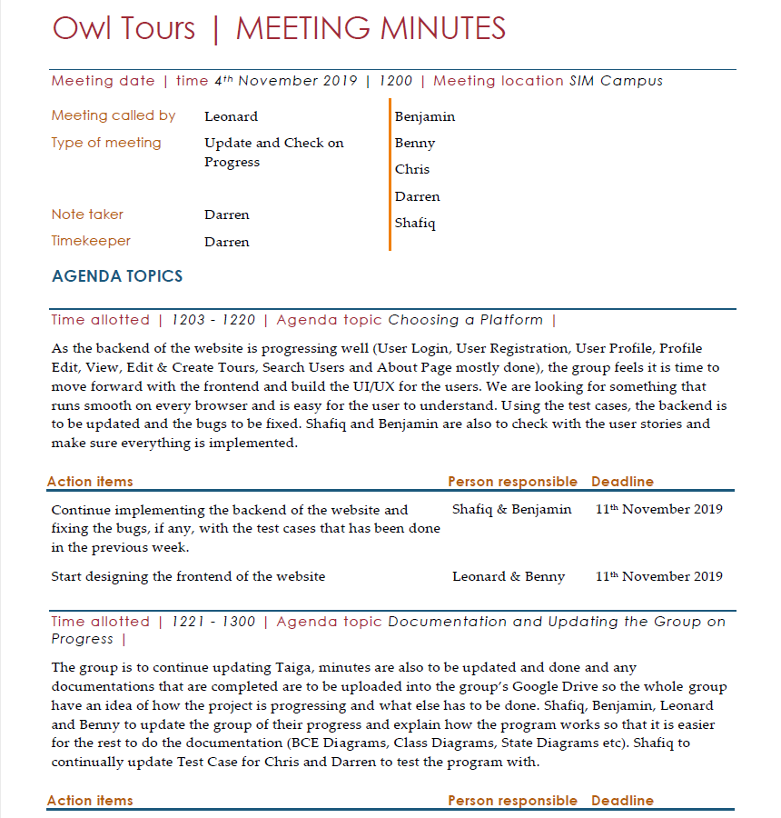

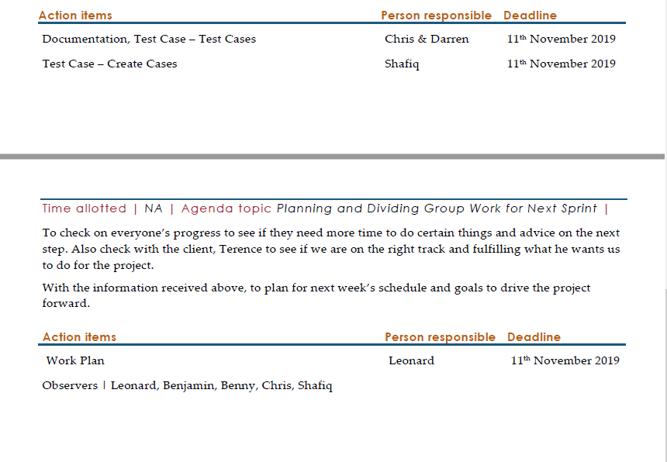

12 November 2019

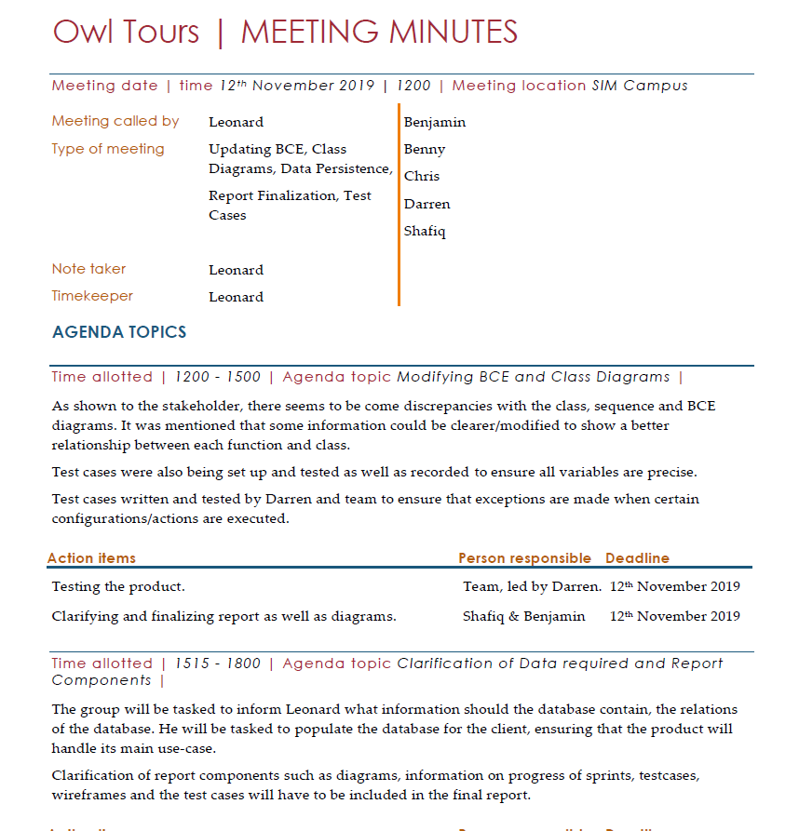

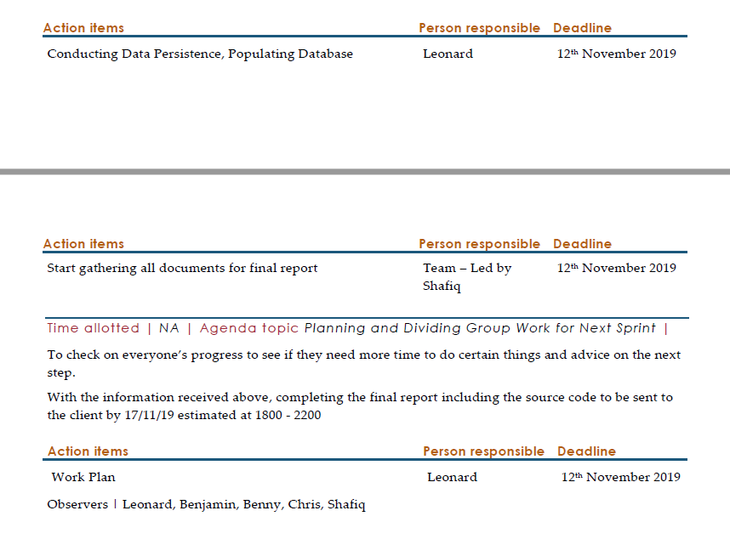

Test Cases

New User

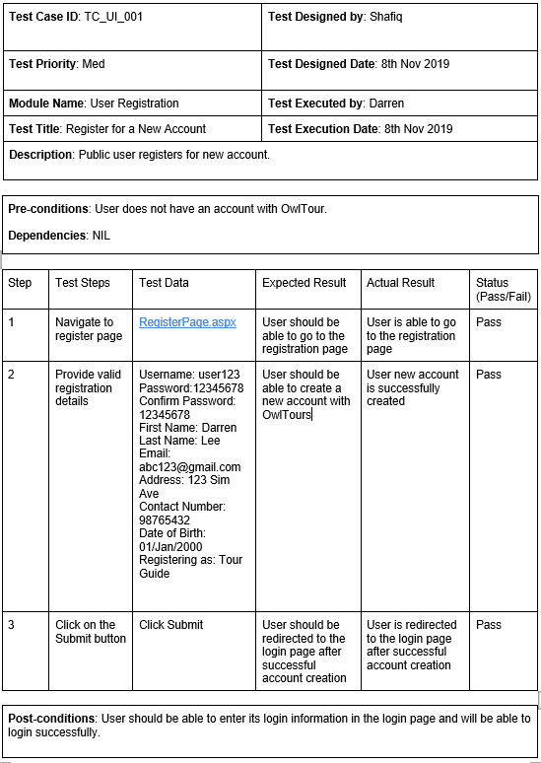

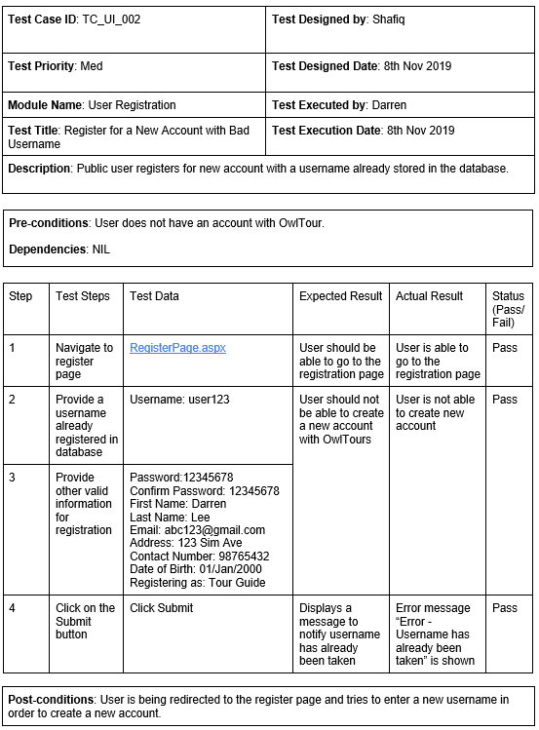

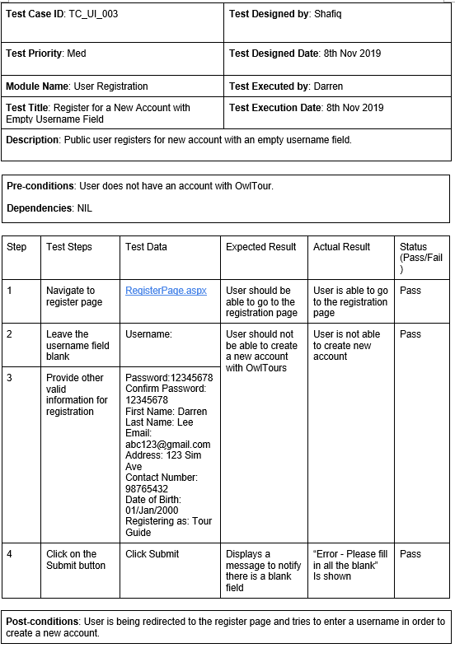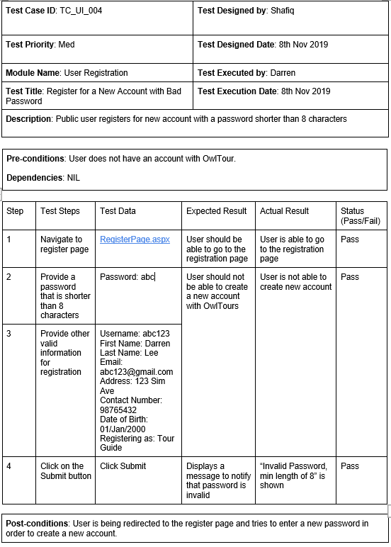

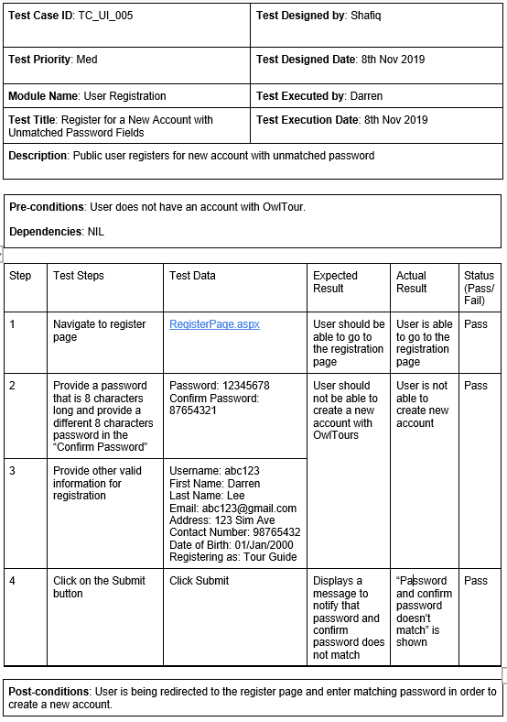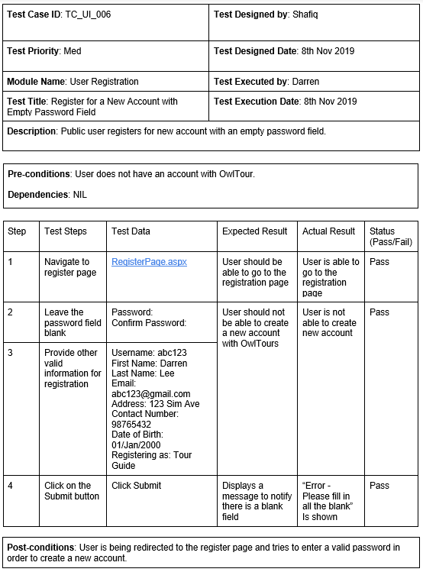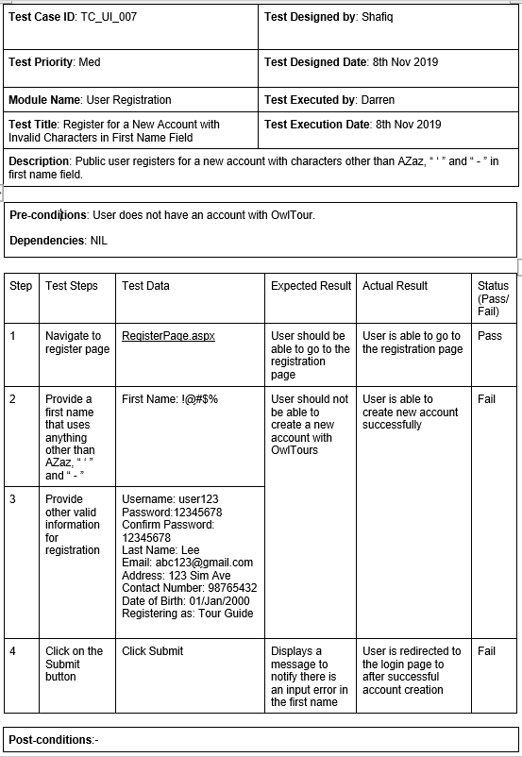 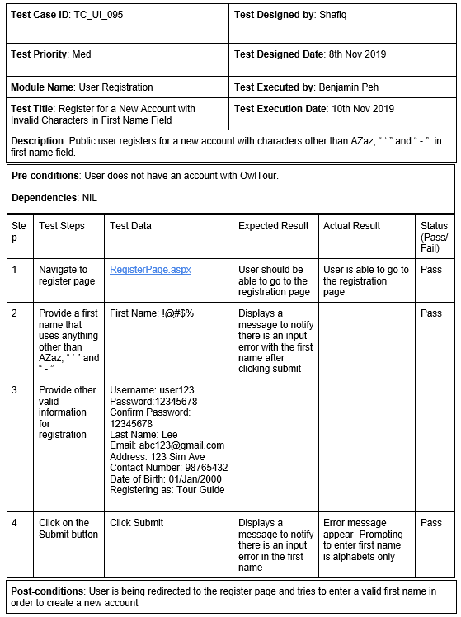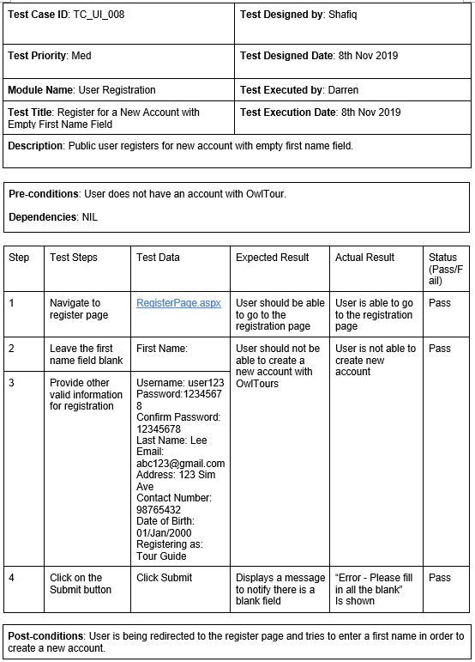

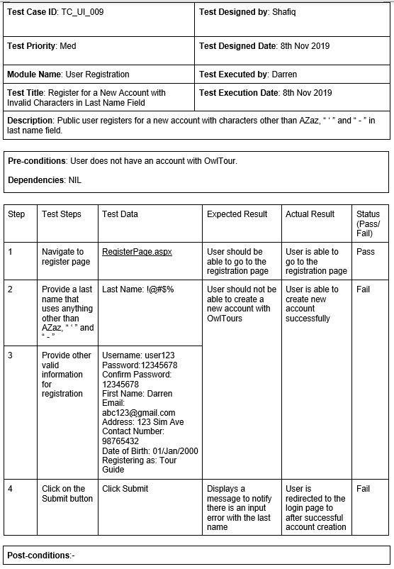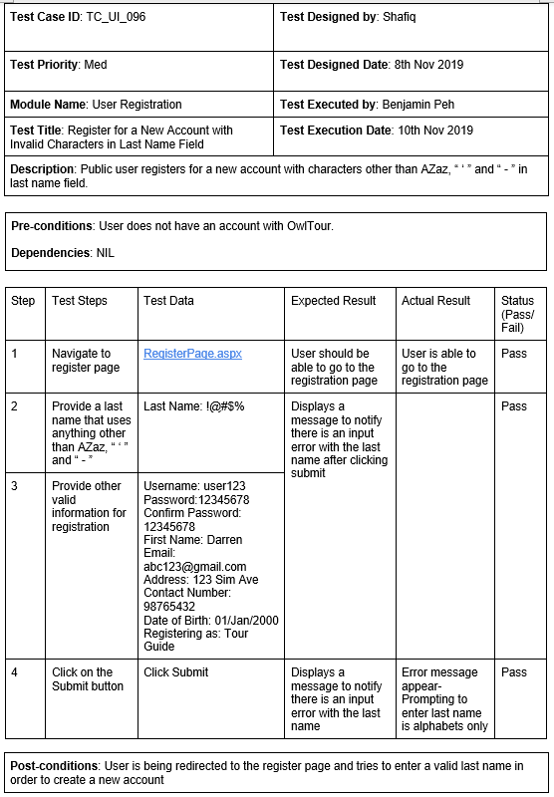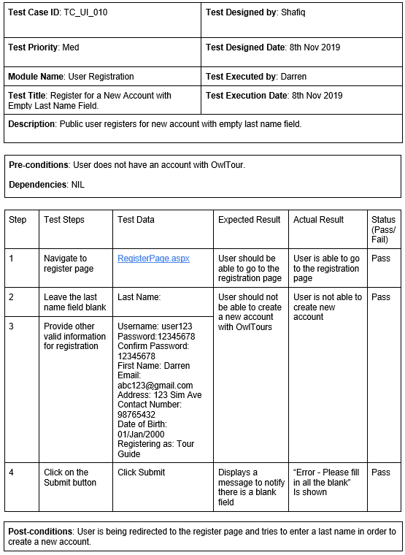

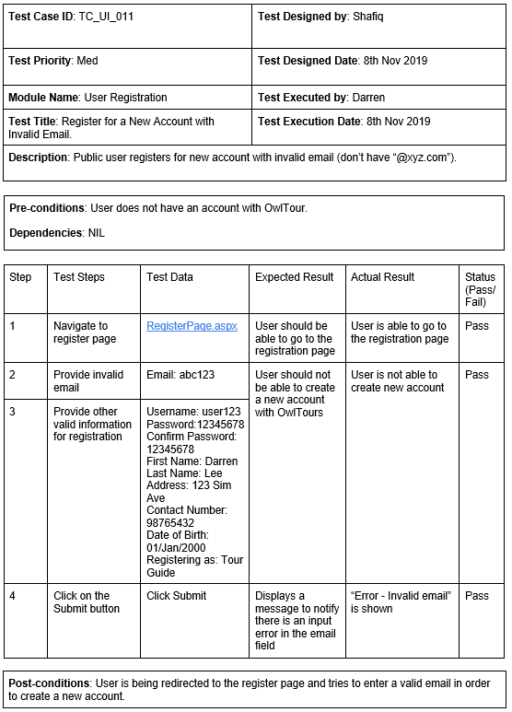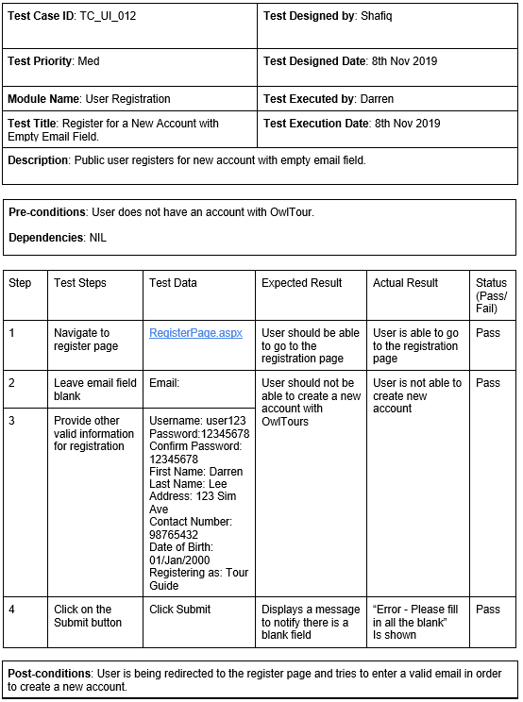

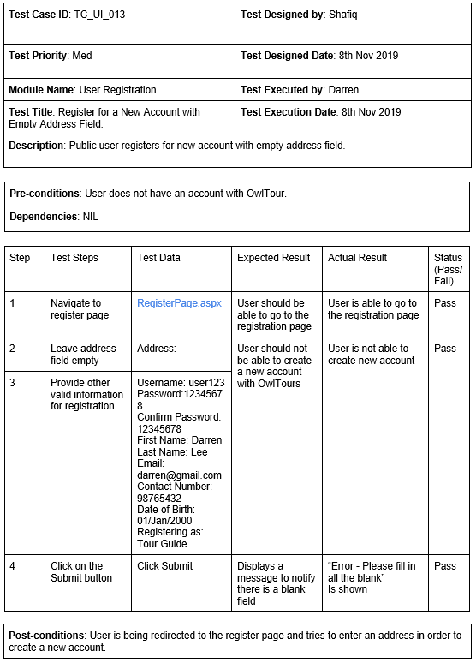

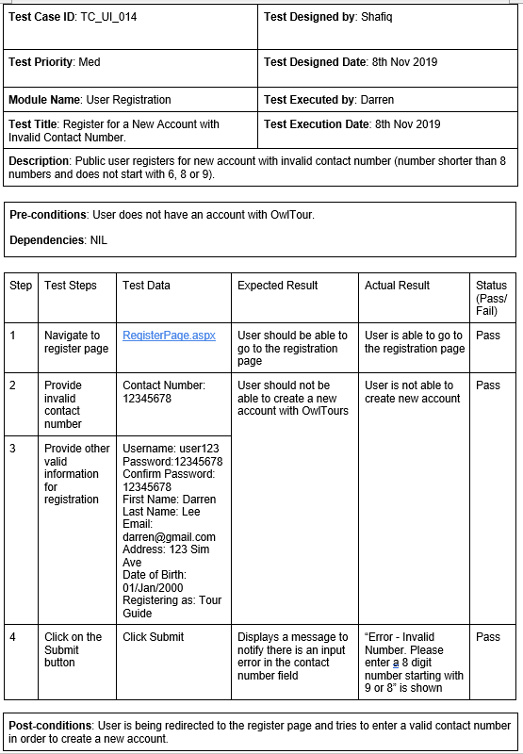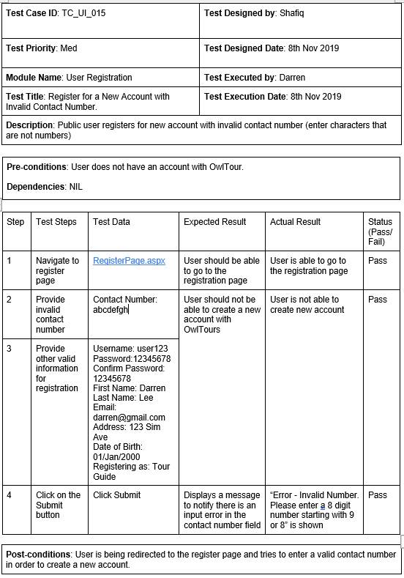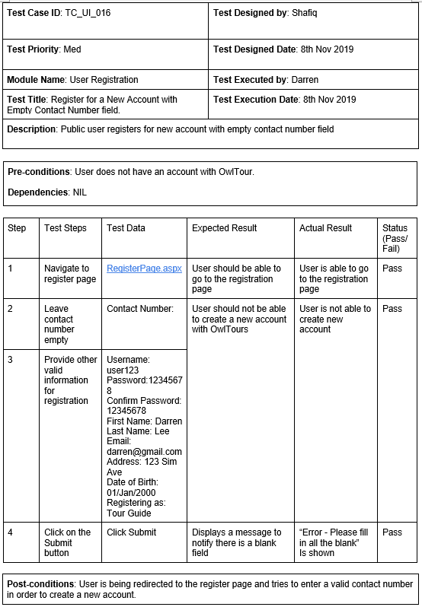

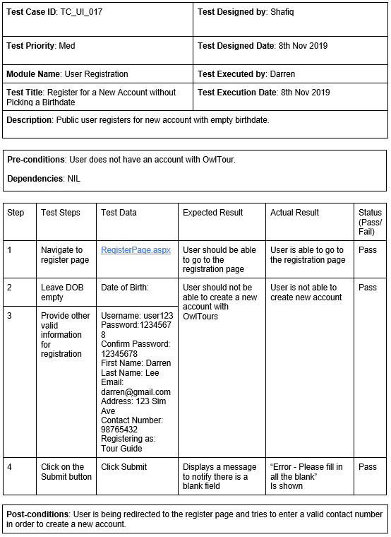

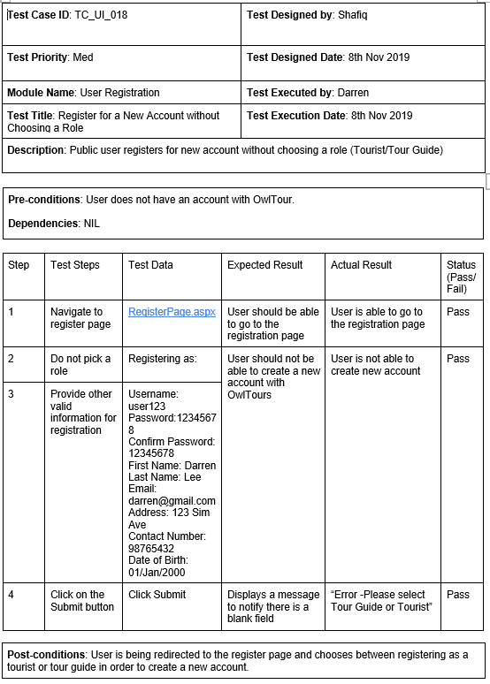

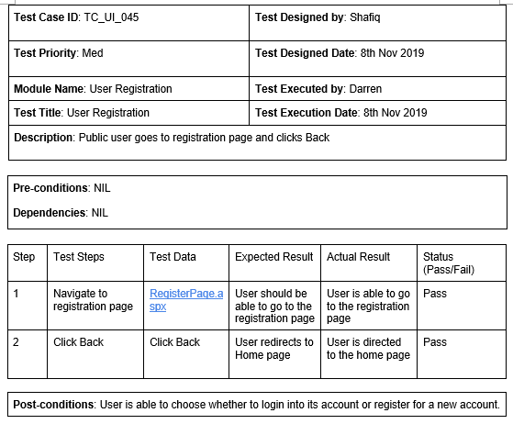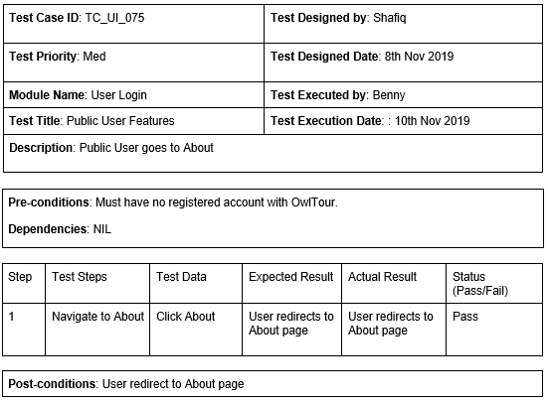

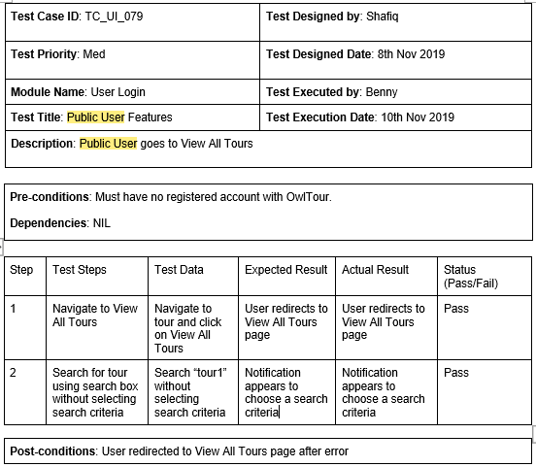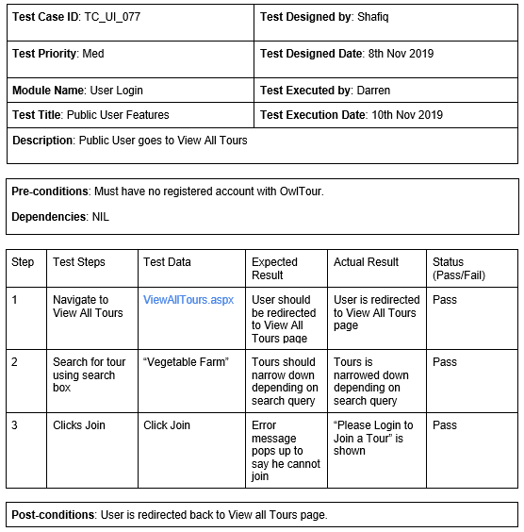

Tourist/Tour Guide/Admin Login